Wrist & Hand Unit

Bones
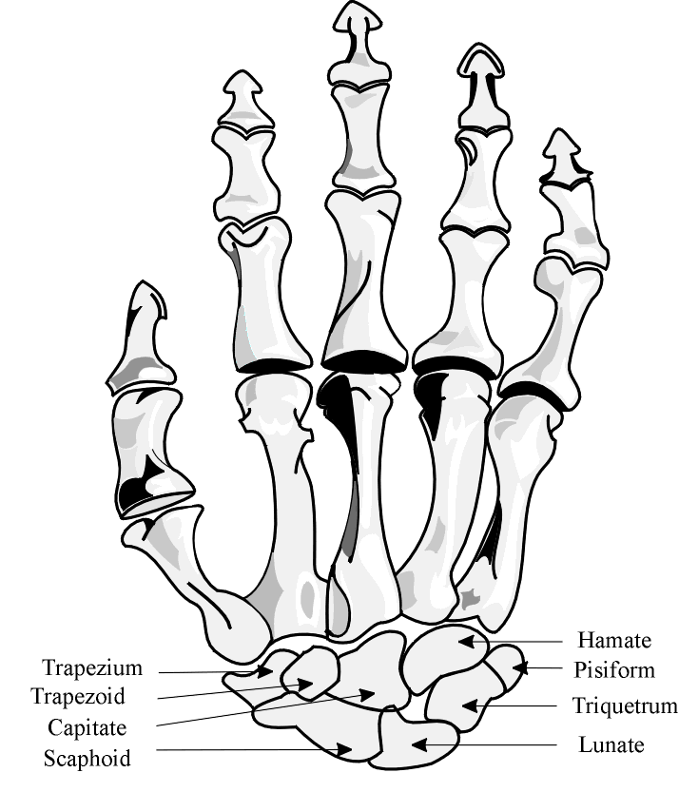
“The Three Children Had Pizza Together Last Night”
Trapezium, Trapezoid, Capitate, Hamate, Pisiform, Triquetrium, Lunate, Navicular (Scaphoid)
Carpalmetacarpal Joint – CMC joint – where the distal carpals and the proximal phalanges (fingers) join; the 1st CMC Joint – Saddle Joint; has lots of motion

Radiocarpal Joint is made up of: ____________________________________
____________________________________
____________________________________
Ulnocarpal Joint is made up of: ____________________________________
____________________________________
Bone Anatomy
Radius – _________________________________________________________ ______________________________________________________________________________________________________________________________________________________________________________________________________

Lister’s Tubercle – ________________________________________________ ______________________________________________________________________________________________________________________________________________________________________________________________________

Ulna – ___________________________________________________________ ____________________________________________________________________________________________________________________________________

Carpals – _________________________________________________________ __________________________________________________________________

Trapezium – ______________________________________________________ __________________________________________________________________

Trapezoid – _______________________________________________________ __________________________________________________________________

Capitate – ________________________________________________________ ____________________________________________________________________________________________________________________________________

Hamate – ________________________________________________________ ____________________________________________________________________________________________________________________________________

Pisiform – ________________________________________________________ ____________________________________________________________________________________________________________________________________

Triquetrium – ____________________________________________________ ______________________________________________________________________________________________________________________________________________________________________________________________________

Lunate – _________________________________________________________ ____________________________________________________________________________________________________________________________________

Navicular – _______________________________________________________ ____________________________________________________________________________________________________________________________________
Osteokinematics
How the bones articulate with each other
Radius P D Meta
As the wrist moves into extension: proximal row – _____________ meta
distal row – ______________ radius

As the wrist moves into flexion: proximal row – _______________ radius
distal row – ______________

The most common carpal dislocation is the __________________________.
The most common carpal fracture is the ____________________________; at the neck.

Carpal Tunnel
- Floor is made of the carpal bones forming an arch
- Ceiling is made by the transverse carpal ligament
- Lateral side is made up of the navicular and trapezium
- Medial side is made up of the pisiform and hamate
- The __________________________ nerve travels through the carpal tunnel. The nerve can become compressed due to edema. Carpal tunnel syndrome can cause atrophy and weakenss of the thenar muscle causing night pain and loss of grip strength. The person will present with a (+) Phalen’s Test.
Motion occurs in the wrist at the radiocarpal joint and the midcarpal joint

4 Motions & Range of Motion
- ____________________________________________
- ____________________________________________
- ____________________________________________
- ____________________________________________
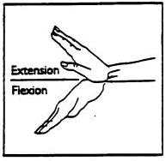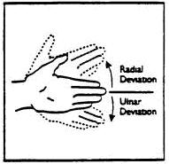

Range of Motion
- Flexion – _______________________
- Extension – _____________________
- Radial Deviation – ________________
- Ulnar Deviation – ________________

