The Performance Learning Center

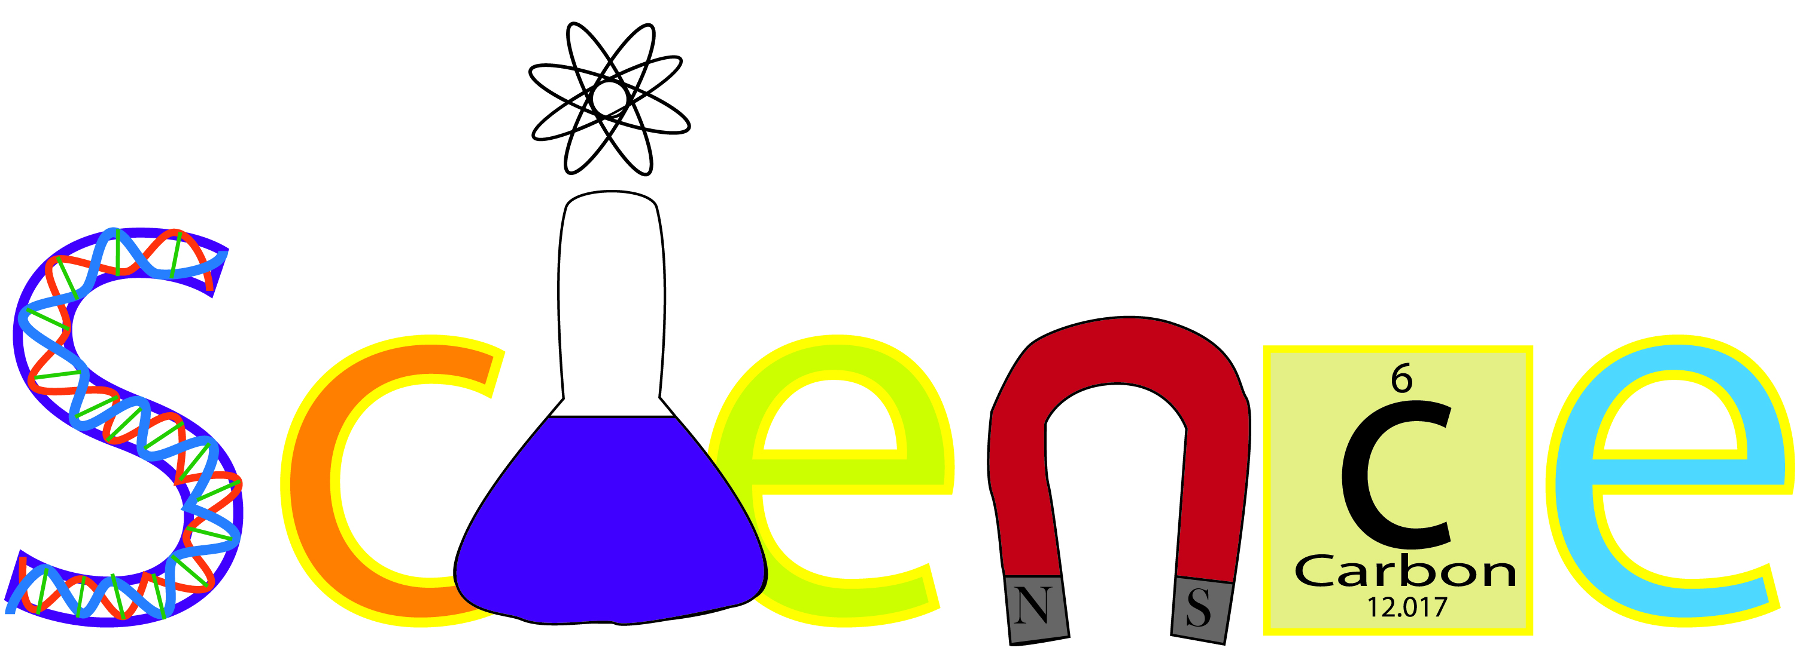 |  | 

Objective: Students will investigate the NC Standard Course of Study in Earth/Environmental Science, Biology, Chemistry, and/or Physical Science. The concepts of science are taught through Edgenuity, labs, practices, and additional resources. Biology students will take the EOC Exam which counts as 25% of the final grade.

Materials Needed Daily:  earbuds/headphones  notebook paper  pencils and pens |  | Honor Code:  Students are expected to demonstrate honesty and integrity. Cheating, plagiarism, forgery, and dishonesty will NOT be tolerated.

Instructor:  Mrs. Hocking  Google phone: (704)629-8665  School phone: (704)260-6800  Email  heather.walker@cabarrus.k12.nc.us |  | In Class:  The student is responsible for staying on pace and completing all required assignments. Edgenuity courses allow you to take notes online. Quizzes, labs, and practices may be worked on at home or at school, but tests and exams may only be taken in the science classroom.
Grading Scale:  A 90-100  B 80-89  C 70-79  D 60-69  F Below 60 |  | Resets:  Students must achieve mastery to be moved forward. The student may reset a quiz/test two times on their own. An additional reset may be requested by reviewing the quiz/test and the student’s notes with the teacher.
Tutoring:

I am available to provide tutoring upon request.

Bathroom Policy:
*Students should ask permission THEN sign out on the clipboard.
*Only one student will be permitted to leave class at a time to go to the
restroom.

Classroom Rules:  - Follow all school-wide rules.  - Show respect.  - Come to class prepared.  - Cell phones can only be out during the class break (last 10 minutes).  - Remain seated until dismissed. |  | 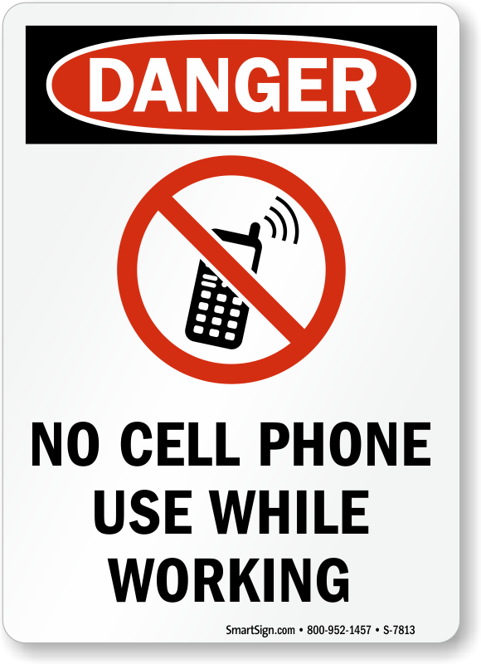

Fire, Tornado, Bomb, and Lock-down Drills:
Stop working immediately
Follow my instructions
Remain quiet, calm, and keep your hands to yourself
If you must leave the classroom or building, do so immediately

