Principles of Projectile Motion

-----------------------------------------------------------------------------------------------------

Any object released into the air is called a projectile.

For example:
- a ball after it has been thrown or hit
- a human body when jumping or diving

All projectiles have a “parabolic” flight path.

Trajectory = the flight path of a projectile.

The trajectory of a projectile consists of a vertical and horizontal component.

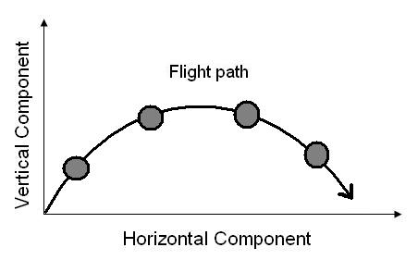

- Vertical Component - gives the projectile height.

Example:
If you throw a ball straight up into the air its motion is only vertical.

B) Horizontal Component – gives the projectile distance.

Example:
A throw from the boundary to the wicket keeper in cricket has a horizontal component as well as a vertical component. It moves along as well as up.
Factors affecting trajectory:

Gravity

Gravity acts on a body or object to give it mass. The greater the weight of an object, the greater the influence of gravity upon it.

Gravity will affect a projectile as it will decrease the height the projectile can obtain.

The force of gravity acts on the object to stop its upward movement and pull it back to earth, limiting the vertical component of the projectile.

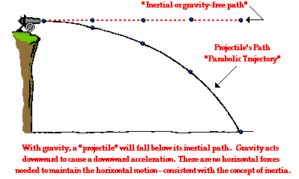

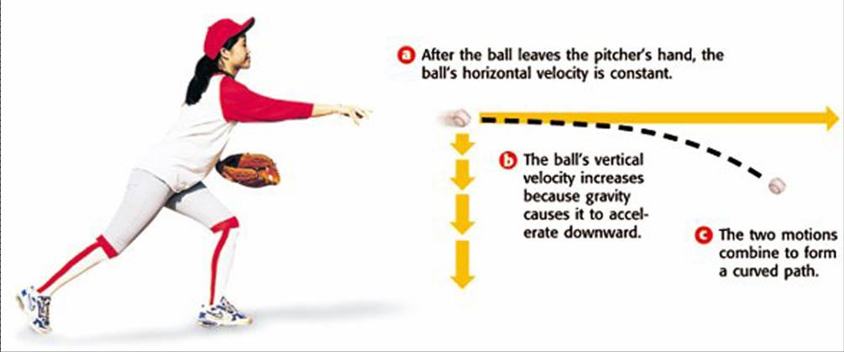
Factors affecting trajectory:

Air resistance

As a projectile moves through the air it is slowed down by air resistance. Air resistance will decrease the horizontal component of a projectile. The effect of air resistance is very small, but needs to be considered if you want to increase the horizontal component of a projectile.

There are several factors that relate to the amount of air resistance acting on a projectile.

- Surface to volume ratio. The larger the surface to volume ratio, the more air resistance will affect the object. For example, a badminton shuttle will have much more air resistance than a golf ball, because of the holes in it.
- The surface of the object. If the surface is rough, the air resistance will be greater.
- Speed. As speed increases, so does air resistance. This is because of friction, for example a space shuttle.
- Mass. The smaller the mass of an object, the more air resistance will affect it. For example a feather, compared to a stone.

Because air resistance affects the horizontal component of a projectiles trajectory, the effect of it can be minimized by lowering the angle of release.

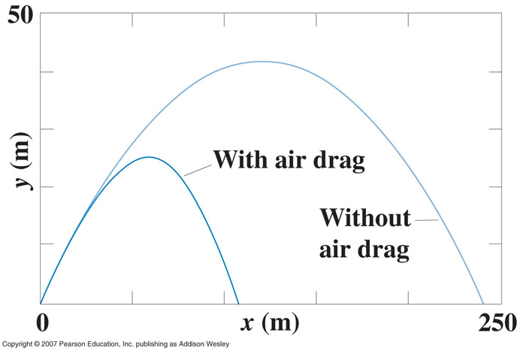

Factors affecting trajectory:
Speed of release

Speed or velocity is directly related to distance. The greater the speed of release, the greater the distance covered in flight.
It is divided into two components:

- Initial Vertical Velocity
- Initial Horizontal Velocity

Having a higher initial vertical velocity will increase the height of the trajectory, resulting in a longer flight path. This would be an advantage in sports which primarily require height, such as tumbles in gymnastics, high jump and ski jumping (tricks).

Having a higher initial horizontal velocity will increase the length of the flight time and therefore the distance covered.

This would be an advantage in sports which primarily require good distance, such as long jump, ski jumping (distance), and vaults in gymnastics.

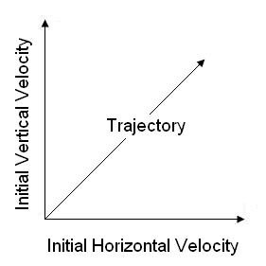

Factors affecting trajectory:

Angle of release

The angle of release changes the relationship between the horizontal and vertical components of a projectile. The ideal angle of release is 45 degrees, assuming there is no air resistance and the take off and landing points are the same height.

If the angle is greater or less than 45 degrees, the distance covered in flight is less. This is because the 45 degrees is half way between vertical and horizontal and will ensure the greatest amount of each component.

If the angle of release is too high for a given activity, the distance gained will be poor.

If the angle of release is too low for a given activity, the projectile will be in the air for less time, gaining less distance.
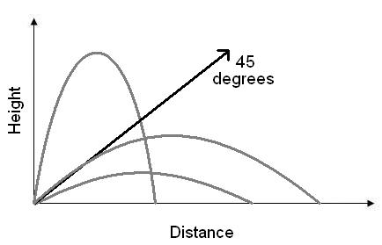

In sporting situations the angle of release is often lower, around 35 degrees to 45 degrees.

This is because the air resistance of the body and because the takeoff point is usually higher than the landing point, e.g., long jump.

Factors affecting trajectory:

Height of release

The higher the level of release, the greater the distance covered in flight. This is because the higher the projectile is released, the longer it will be in the air. The horizontal component will be acting on the projectile for longer.

For example:
A golfer hitting a ball off the top of a hill would hit it further than a golfer at the bottom of the hill. The ball will stay in the air longer so will have a greater chance to gain distance. This assumes that the same golf club, technique and force is being used.

In javelin, to gain more distance, athletes will hold the javelin up higher to create a greater height of release.

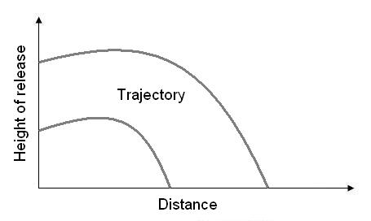

There is a relationship between height of release and angle of release.
-As the height of release increases, the angle of release decreases.
-As the height of release decreases, the angle of release increases.

For example, when shooting, basketball players will have a lot lower angle of release than shorter basketball players to shoot the ball at the same hoop height.

Factors affecting trajectory:

Spin

The amount and direction of spin acting on a projectile will directly affect the distance a projectile will travel. The reason for this is the air pressure acting on the ball.

Example:

In a tennis shot, topspin gives poorer distance compared to backspin.
Range is decreased with topspin.
Range is increased with backspin.

A topspin shot creates a region of high pressure on top of the ball, and a region of low pressure below. Air moves from a region of high to low pressure and as a consequence the ball will dip suddenly, decreasing the vertical component of the trajectory and in turn, the distance travelled.

In a backspin shot, a region of high pressure is created under the ball, and low pressure above the ball. Air moves from high to low pressure. The air pressure acting on the ball will cause it to stay up longer, increasing the vertical component of the trajectory, therefore increasing the distance travelled.

Golfing example

