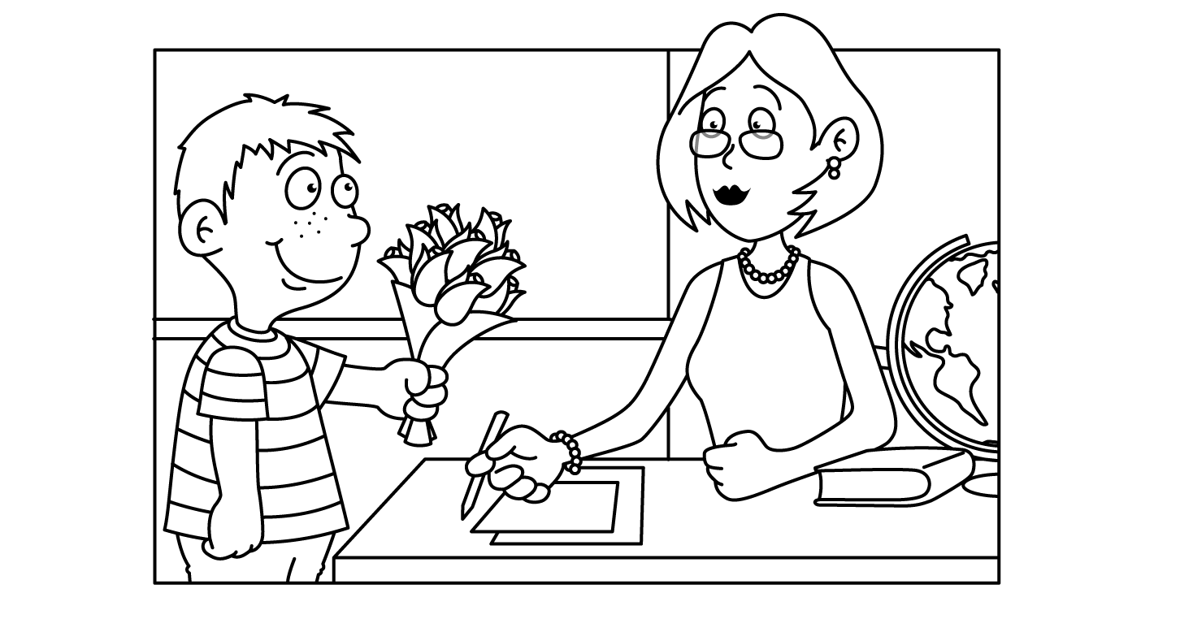
Please remember to send in this month’s snack for the class!
¡Recuerde enviar el refrigerio de este mes para la clase!

May in Room 501
Sunday | Monday | Tuesday | Wednesday | Thursday | Friday | Saturday
 | 1  C | 2  D  Boosterthon begins | 3  E | 4  F | 5  G  Baggy Books Due | 6
7 | 8  A | 9  B | 10  C  Zaxby’s Night  5-9pm | 11  D  Fun Run 9:40 | 12 E  Baggy Books Due  MOTHER’S  DAY TEA  1:00 | 13
14 | 15  F | 16  G | 17  A | 18  B  PTO Night of the Arts K-2  7 pm | 19  C  Baggy Books Due  SPIRIT DAY | 20
21 | 22  D | 23  E | 24  F | 25  G | 26  A  20th WHES celebration | 27
28 | 29  NO SCHOOL | 30  B | 31  C | 1  D | 2  E  WATER DAY

© 2004 by Education World®. Education World grants users permission to reproduce this work sheet for educational purposes only.

