Turning on the Mac

Getting your Mac out of the Box
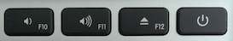
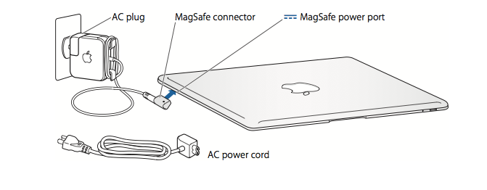
Press the power button briefly to turn on your MacBook
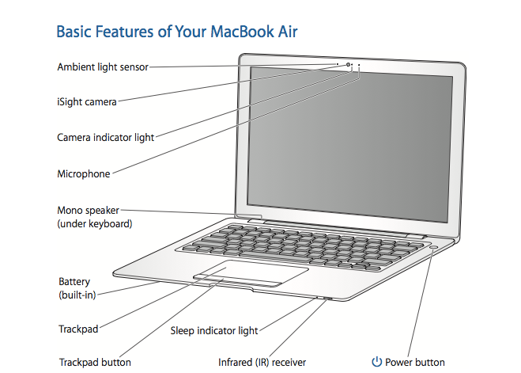
Getting to know your Mac
Ambient light sensor
The ambient light sensor adjusts the illuminated keyboard according to the available light in your operating environment.
Built-in iSight camera and camera indicator light
Videoconference with others using iChat AV, snap pictures with Photo Booth, or capture video with iMovie. The indicator light glows green when the iSight camera is operating.
Built-in microphone
Capture sounds directly with the microphone (located to the right of the iSight camera) or talk with friends live using the included iChat AV application.
Built-in mono speaker Listen to music, movies, games, and multimedia files.
Built-in rechargeable battery
Run your MacBook Air using battery power when you are away from a power outlet.
Trackpad and trackpad button
Move the pointer, click, double-click, scroll, zoom, and more, using one or more fingers on the trackpad. For details, see “Using the Trackpad and Keyboard” on page 32.
Sleep indicator light
A white light pulses when your MacBook Air is in sleep.
Built-in infrared (IR) receiver
Use an optional Apple Remote (sold separately at www.apple.com/store) with the IR receiver to control Front Row and Keynote on your MacBook Air
Power button
Turn your MacBook Air on or off, or put it to sleep. Press and hold to restart your MacBook Air during troubleshooting.
---------------------------------------------------------------------------------------------

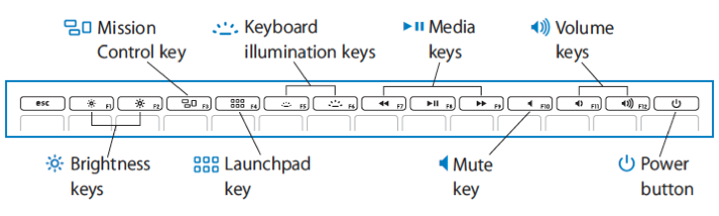
Function (fn) key
Press and hold this key to activate customized actions assigned to the function keys (F1 to F12). To learn how to customize function keys, choose Help > Mac Help from the menu bar and search for “function keys.”
¤ Brightness keys (F1, F2) Increase ( ) or decrease ( ) the brightness of your MacBook Air display.
Exposé All Windows key (F3)
Open Exposé for quick access to all your open windows.
Dashboard key (F4)
Open Dashboard to access your widgets.
Keyboard illumination keys (F5, F6)
Increase (o) or decrease (ø) the brightness of the keyboard illumination.
Media keys (F7, F8, F9) Rewind (]), play or pause (’), or fast-forward (‘) a song, movie, or slideshow.
Mute key (F10)
Mute the sound coming from the built-in speaker or headphone jack.
Increase (-) or decrease (–) the volume of the sound coming from the built-in speaker or headphone jack.
Volume keys (F11, F12)
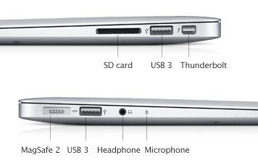
Mac Book Parts

SD card USB 3.0 ports (2) Thunderbolt MagSafe 2 Headphone Microphone
Descriptions:
̄MagSafe power port Plug in the included 60W MagSafe Power Adapter to recharge the MacBook battery. Attach a lock and cable (available separately) to prevent theft. Note: Adapters and other accessories are sold separately at www.apple.com/store.
Thunderbolt port
Thunderbolt port allows for connection to VGA/DVI adapters, Ethernet, and, external DVD/CD, and Firewire connectors.
Two USB (Universal Serial Bus) 3.0 ports
Connect a modem, iPod, iPhone, mouse, keyboard, printer, digital camera, and more to your MacBook Air. You can connect one high-powered external USB device. You can also connect USB 2.0 devices.
Audio in/optical digital audio in port
Connect your MacBook to a line-level microphone or digital audio equipment.
Headphone out/optical digital audio out port
Connect external speakers, headphones, or digital audio equipment.
Dock

The dock can be customized to meet your personal needs. The following items are usually on the dock.

Customize the Mac OS X desktop and set preferences
You can quickly make the desktop look the way you want using System Preferences. Choose Apple () > System Preferences from the menu bar or click the System Preferences icon in the Dock. System Preferences is your command center for most settings on your MacBook Air.


To put your MacBook Air to sleep, do one of the following:
-Close the display
-Choose Apple () > Sleep from the menu bar.
-Press the power button and click Sleep in the dialog that appears.
-Choose Apple () > System Preferences, click Energy Saver, and set a sleep timer.
To wake your MacBook Air:
-If the display is closed, simply open it to wake your MacBook Air.
-If the display is already open, press the power button or any key on the keyboard.
Shutting Down Your MacBook Air
If you aren’t going to use your MacBook Air for a day or two, it’s best to shut it down. The sleep indicator light goes on briefly during the shutdown process.
To shut down your MacBook Air, do one of the following:
-Choose Apple () > Shut Down from the menu bar.
-Press the power button and click Shut Down in the dialog that appears.
Using the Trackpad
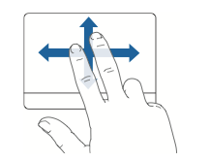
Two-finger scrolling lets you drag to scroll quickly up, down, or sideways in the active window. This option is on by default.

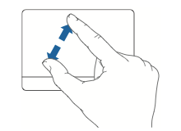
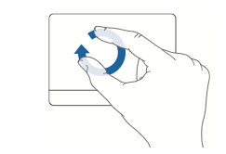
Two-finger pinching lets you zoom in or out on PDFs, images, photos, and more.
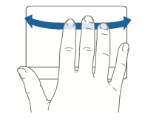
Two-finger rotating lets you rotate photos, pages, and more.
Three-finger swiping lets you rapidly page through documents, move to the previous or next photo, and more.
Other Ways to Use your TrackPad
- Use one finger to point, tap to click, and drag items on your screen.
- Drag two fingers up, down, or sideways to scroll in an active window.
- Use two-finger pinching to zoom in or out on PDFs, images, photos, and more.
- Use two-finger rotating to rotate photos, pages, and more.
- Swipe three fingers to quickly page through a document, move to the previous or next photo, and more.
- Swipe four fingers left or right to cycle between full-screen applications.
- Swipe left from the right edge to open the Notification Center in Mountain Lion.
- Swipe up with three fingers to open Mission Control.
- Pinch close with thumb and three fingers to open Launchpad.
Spread with thumb and three fingers to show the desktop.
Running Your MacBook Air on Battery Power
- When the 45W MagSafe Power Adapter is not connected, your MacBook Air draws power from its built-in rechargeable battery. The length of time that you can run your MacBook Air varies, depending on the applications you use and the external devices connected to your MacBook Air. Turning off features such as AirPort Extreme or Bluetooth wireless technology can help conserve battery charge.
- If the battery runs low while you are working, attach the power adapter that came with your MacBook Air and let the battery recharge. When the power adapter is connected, the battery recharges whether the computer is on, off, or in sleep. The battery recharges more quickly, however, when the computer is off or in sleep.
- You can determine whether the battery needs charging by looking at the indicator light on the MagSafe connector. If the light is glowing amber, the battery needs to be charged. If the light is glowing green, the battery is fully charged.
- You can also check the amount of battery charge left by viewing the Battery status icon in the menu bar.
- The battery charge level displayed is based on the amount of power left in the battery with the applications, peripheral devices, and system settings you are currently using.
- To conserve battery power, close applications and disconnect peripheral devices not in use, and adjust your Energy Saver settings.
Troubleshooting Your Mac
- If your MacBook Air doesn’t respond or the pointer doesn’t move On rare occasions, an application might “freeze” on the screen. Mac OS X provides a way to quit a frozen application without restarting your computer. Quitting a frozen application might allow you to save your work in other open applications. To force an application to quit: Press Command -Option-Esc or choose Apple () Force Quit from the menu bar. The Force Quit Applications dialog appears with the application selected. Click Force Quit.
The application quits, leaving all other applications open. If you need to, you can also restart the Finder from this dialog.
Next, save your work in any open applications and restart the computer to make sure the problem is entirely cleared up.
If you are unable to force the application to quit, press and hold the power (®) button for a few seconds until the computer shuts itself down. Wait 10 seconds and then turn on the computer.
- Make sure the power adapter is plugged into the computer and into a functioning power outlet. Be sure to use the 45W MagSafe Power Adapter that came with your MacBook Air. If the power adapter stops charging and you don’t see the indicator light on the power adapter turn on when you plug in the power cord, try unplugging and replugging the power cord to reseat it.
- Check whether the battery needs to be recharged. If the light on the power adapter glows amber, the battery is charging. See “Running Your MacBook Air on Battery Power” on page 34.
- Press and release the power (®) button and immediately hold down the Command Option, P, and R keys simultaneously until you hear the startup sound a second time. This resets the parameter RAM (PRAM).
- If your MacBook Air freezes during startup, or you see a flashing question mark, or the display is dark and the sleep indicator light is glowing steadily (not in sleep) Contact your Technology Facilitator
- If the display suddenly goes black or your MacBook Air freezes
Try restarting your MacBook Air.
- Unplug any devices that are connected to your MacBook Air, except the power adapter.
Press the power (®) button to restart the system.
- Let the battery charge to at least 10 percent before plugging in any external devices and resuming your work. To see how much the battery has charged, look at the Battery status icon in the menu bar. The display might also darken if you have energy saver features set for the battery.
To get Mac Help
- Click the Finder icon in the Dock (the bar of icons along the edge of the screen.
- Click the Help menu in the menu bar and do one of the following:
a. Type a question or term in the Search field, and select a topic from the list of results or select Show All Results to see all topics.
b .Choose Mac Help to open the Mac Help window, where you can click links or type a search question.
Dock
The dock can be customized to meet your personal needs. The following items are usually on the dock.

Adding and removing Dock items
Adding an application to the dock
-Click the Launchpad icon in the Dock
-Drag the application icon to the Dock;
(The icons in the Dock will move aside to make room for the new one.)
Adding a file or folder to the Dock
-Drag its icon from any Finder window (or the desktop) and drop it on the Dock. the Dock.
To remove an item from the Dock,
-Drag its icon an inch or more off the Dock and wait a couple seconds, then release;
-The icon will disappear
-There are some icons that you can't remove from the Dock, such as the Trash and the Finder.

Moving Items to the Trash
- Drag the item from the Finder and drop it onto the Trash icon in the Dock.
-The item will remain in the Trash folder (click the Trash icon to view its contents) until you either move it out of the Trash (if you decide to keep it) or empty it.
-Drag the item from the Finder and drop it onto the Trash icon in the Dock.
-The item will remain in the Trash folder (click the Trash icon to view its contents) until you either move it out of the Trash (if you decide to keep it) or empty it. From the Finder menu, choose Empty Trash
OR Click on the trash and on Empty Trash
The menu bar
Along the top of the screen is the menu bar. Its choices change based on which application you're using,

OR if you're in the Finder. Use status menus on the right side of the menu bar for things like sound, data and time, Wi-Fi connection, Spotlight, and your online chat status.
Status Menus

Open Spotlight from the menu bar. Use Spotlight to search for files such as documents, emails, dates in Calendar, and webpages that you've visited.

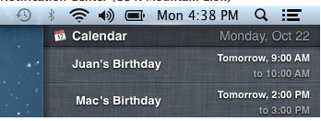
Notification Center

- Use Notification Center to view notifications from Messages, Calendar, Mail, Reminders, Twitter, Facebook, and other third-party apps.

Close, minimize, and zoom windows
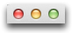
Every Finder, application, and document window has three colored buttons (red, yellow, and green) in the upper left corner.

The red close button closes the window. You can also use the Command-W keyboard shortcut.
The yellow minimize button (or Command-M keyboard shortcut) shrinks the window into the Dock. Click the window icon in the Dock to restore it.
The green zoom button will enlarge the window's size to show as much content as possible without a scroll bar. Click it again to return the previous window size.

System Preferences


System Preferences controls system-wide settings ("global" settings), and is available from the Apple menu at the upper-left corner of the screen, or from the dock below. System Preferences lets you:
- Adjust things like your screen resolution, keyboard control, mouse control, sound, printer settings, sharing settings, accounts, and more.

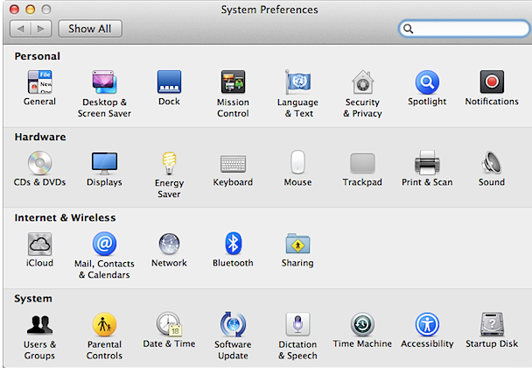

The Finder
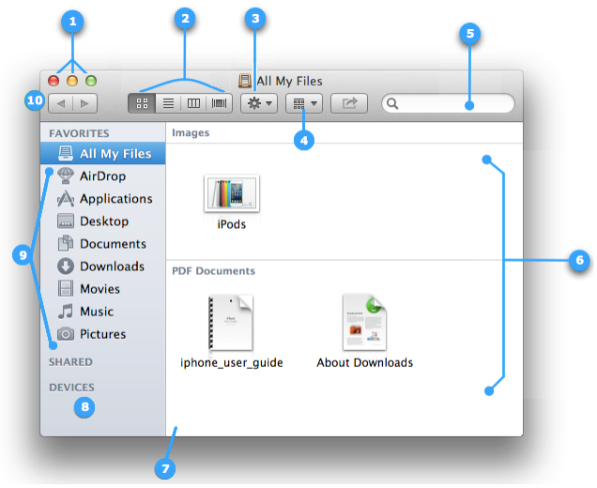
Finder windows
The Finder allows you to visually access everything on your Mac, including applications, hard disks, files, folders, and DVDs.
To see your files, click the Finder icon in the Dock, then click "All My Files" in the sidebar.

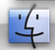

- Window close, minimize and zoom buttons.
- Finder window View buttons:
Icon view - Used to display the contents of your folder as a series of icons.
List view - Used to display your folder in a spreadsheet-style manner. Choose Show View Options from the View menu to add / remove attribute columns. You can change the sorting from ascending order to descending order and back again by clicking on the attribute column title. Column view - Used to display the hierarchy of your folders where each column represents a folder.
Cover Flow view - Used to display the contents of your folder Action Menu - Quick access to Finder functions for highlighted items, such as Get Info, Move to Trash, and Services.
- Item Arrangement button - In any view, you can organize the window by clicking the item arrangement Search Field - Start typing a word or phrase and Spotlight will search your Mac for any matches.
- Right pane - The contents of a selected folder are shown in this pane.
- Pane edge - Drag to resize.
- Devices - A device connected to your computer, such as a DVD, USB device, or your Time Machine backup disk.
- Sidebar - Items are grouped into categories: Favorites, Shared, and Devices—the top portion has Favorites which contains quick access to All My Files, Applications, Desktop, Documents, Downloads, Movies, Music, and Pictures.
- Back / Forward buttons - As you move to different places in the Finder window, you can use the back button to return one step back and the forward button to go forward.

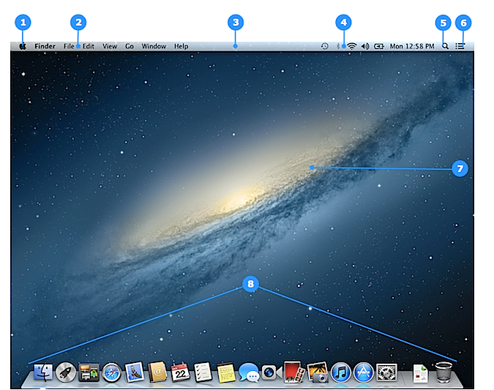

- Apple menu () - Access Software Update, System Preferences, Sleep, Shut Down, and more.
- Application menu - Contains menus for the application you're currently using.
- Menu bar - Contains the Apple menu, active application menu, status menus, menu bar extras, Spotlight icon, and Notification Center icon (OS X Mountain Lion).
- Status menu - Shows the date and time, status of your computer, or gives you quick access to certain features—for example, you can quickly turn on Wi-Fi, turn off Bluetooth, or mute your computer's volume.
- Spotlight icon - Click it to bring up the Spotlight search field, where you can search for anything on your Mac.
- Notification Center icon - Click it to view Notification Center, which consolidates your notifications from Messages, Calendar, Mail, Reminders, and third-party apps.
- Desktop - This is where your applications' windows will appear.
- The Dock - Quick access to your most frequently used applications, folders, and files. With a single click the application, folder, or file opens.

Organize your desktop files and folder
- You can organize your desktop files by grouping them into folders on your desktop.
- Just select the items you want to group, Control-click one of the selected items, and then choose "New Folder with Selection" from the shortcut menu.
Then enter a name for the folder.
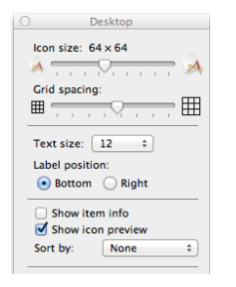
To change your desktop view options,
Click the desktop, and then choose View > Show View Options from menu bar.
You can try the different settings to see which ones you like—you will immediately see the effects of your changes.
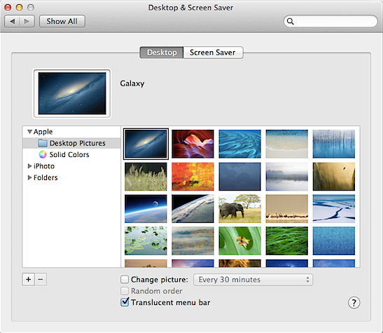
Change your Background
You can change the picture that's displayed on your Mac's desktop. You can choose one of the desktop pictures that comes with your Mac, a solid color, or one of your own pictures.

- Click the Launchpad icon in the Dock, and then click System Preferences. OR click the System Preferences icon in the Dock.
- Click Desktop & Screen Saver, and then click Desktop.
- To select the kind of desktop picture you want to use, do one of the following:
  - To use an image that came with your Mac, select a folder under the Apple section.
  - To use a solid color, select "Solid Colors" under the Apple section.
  - To use your own picture, select the Picture folder under "Folders," if the picture you want is stored in your Pictures folder. If your image is in another folder, click the Add button (+), then find and select the folder that your picture is in. Then, click Choose.
- Select the picture you want in the box on the right.
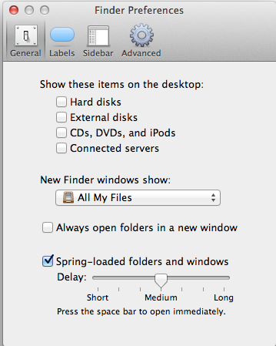
Desktop Preferences

  - Click the desktop.
  - Choose Finder > Preferences, then click General.
  - In the "Show these items on the desktop" section, select the items you want to appear on your desktop, such as hard disks and external disks.
Stacks

A stack is a Dock item that gives you fast access to a folder.
Customize a Stack by right-clicking or control-clicking on the stack.

- Sort by - You can select to have items sorted by Name, Date Added, Date Modified, Date Created, or Kind.
- Display as - Displays the icon in the Dock as the folder's actual icon or as a stack of icons of the folder contents.
- View content as :
  - Fan - Shows folder content in the Fan stack, organized by your sort option.
  - Grid - Shows folder content in the Grid stack, organized by your sort option.
  - List - Shows the folder contents as a list, organized by your sort option. Each sub-folder opens another list and so on, until you reach the end of the directory structure. To open an application or document, simply click it.
  - Automatic - This lets OS X determine the best view content option. When there are a few items, the Fan stack is used. Once you have loaded your folder with enough items, OS X changes your view content type to the Grid stack.

Mission Control

View of all the open windows and apps on your Mac. Just swipe up with three fingers on your trackpad or click the Mission Control icon in the Dock, and your desktop zooms out to Mission Control.
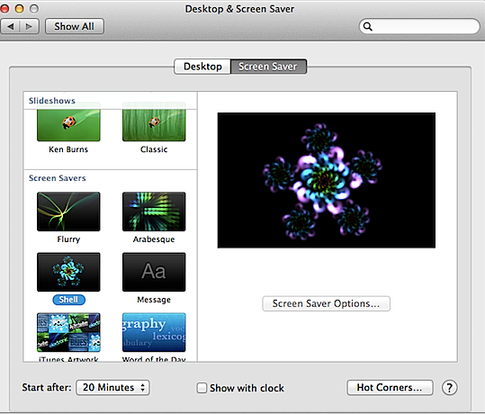
To change your screen saver:
- From the Apple () menu, choose System Preferences.
- From the View menu, choose Desktop & Screen Saver.
- Click the Screen Saver tab to display the Screen Saver preferences. Screen Savers appear in the left pane. The right pane displays a preview of the selected screen saver.
- Select one of the Screen Savers in the left pane.
- To create a slideshow screen saver, do one of the following:
- In the Screen Saver preferences window, select one of the slideshow choices, such as Floating, Reflections, Origami, Shifting Tiles, and so forth. A small preview appears in the right pane. To see a full-screen preview, hover your cursor over the right pane and click the "Preview" button.
Change the source for your
If you have iPhoto installed (a part of iLife), you can choose a recent iPhoto Event or your photo library.
- You can also choose a folder of images on your computer to use for your slideshow.

