HNRS Chemistry
Lecture 7-1
Colligative Properties

How do the physical properties of a solvent change with the addition of a solute? Colligative properties of a solution are those properties that depend on the number of dissolved particles and not the identity of the dissolved particles. We will study three colligative properties: 1. vapor pressure 2. freezing point 3. boiling point.

When we studied the states of water, we learned to define the freezing point of a liquid and the boiling point of a liquid in terms of the vapor pressure of the liquid. The freezing point of a liquid is the temperature where the vapor pressures of the liquid and solid states are the same. The boiling point of a liquid was defined as the temperature where the vapor pressure of the liquid equaled the atmospheric pressure. All of the possible freezing points and boiling points are found on the phase diagram.

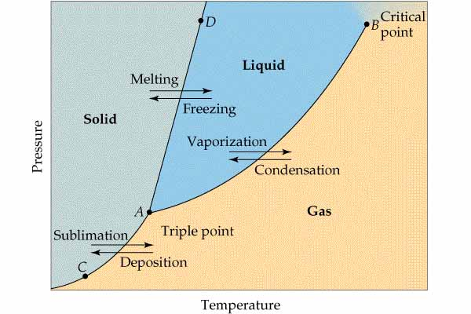

The y-axis of a phase diagram is the vapor pressure of the particular state(s).

What happens to the vapor pressure of water if a solute is added? Raoult’s law states that the vapor pressure of a solution (VP_{solution} is equal to the mole fraction of the solvent (X_{solvent}) times the vapor pressure of the pure solvent (VP_{solvent}).

Since the mole fraction of the solvent must be less than one, we see that the vapor pressure of the solution must be less than that of the pure solvent. This drop in vapor pressure with the addition of the solute can be explained in two ways: 1. the presence of the solute particles on the surface of the liquid block the solvent particles from escaping and 2. the solvent particles may be more strongly attracted to the solute particles making the chances of evaporation less likely.

If the vapor pressure of the solution is less than that of the pure solvent, then we would also expect the freezing point and boiling point of the solution to be different from that of the pure solvent. The phase diagram below shows how the vapor pressure curve of the solution differs from that of the pure solvent.

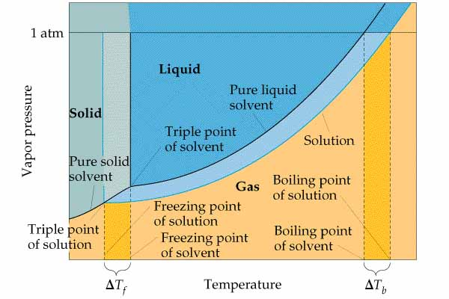

We can see from the diagram that the freezing point of the solution will be lower than that of the pure solvent. We can also see that the boiling point of the solution will be higher than that of the pure solvent.

What factors determine how much the freezing point of the solvent will be depressed when the solute is added? The higher the concentration of dissolved particles, the greater will be the freezing point depression. The concentration of dissolved particles depends on the molality of the solution and on the number of dissolved particles formed per mole of solute dissolved. For example, remember that one mole of NaCl produces two moles of dissolved ions. This factor is called the van’t Hoff factor, i. The concentration of dissolved particles is the product of the molality of the solution and the van’t Hoff factor. Each solvent has its own characteristic freezing point constant called the molal freezing point constant, k_{fp}. These three factors determine the change in the freezing point of a solvent as solute is added.

The change in the boiling point is determined by the same factors: the van’t Hoff factor, the molality of the solution, and a constant called the molal boiling point constant.

Let’s calculate the vapor pressure, freezing point, and boiling point of a solution prepared by dissolving 30.0 g of NaCl in 100.0 g of water at 25ºC.

To calculate the vapor pressure of the solution, we need to know the mole fraction of the water in the solution. The solution contains three kinds of particles, water molecules, sodium ions, and chloride ions. The van’t Hoff factor for NaCl is two according to the equation showing the dissociation in water.

We need to calculate the number of moles of each of these particles in the solution.

Now we can use Raoult’s law to calculate the vapor pressure of the saltwater. We need to look up the vapor pressure of pure water at 25ºC.

We need to calculate the molality of the solution to find the freezing point and boiling point of the solution.

We need to look up the molal freezing point and boiling point constants for water to calculate the changes in freezing point and boiling point of the water. We are assuming that we are at standard pressure.

HNRS Chemistry Name_______________________________
HW 7-1 Period______ Date____________________
Colligative Properties

- What is a colligative property?

- Explain WHY adding salt to water lower the vapor pressure of the water?

- What is Raoult’s Law?

- The vapor pressure of pure water at 25°C is 24 torr (mm Hg). What will be the vapor pressure of a solution prepared by dissolving 5 moles of a nonvolatile nonelectrolyte in 5 moles of water?

- Define the freezing point and boiling point of a liquid in terms of the vapor pressure of the liquid.

- What happens to the freezing point and boiling point of a solvent as a nonvolatile solute is added? Why?

- Why does the addition of 10g of C₆H₁₂O₆ lower the freezing point of water more than the addition of 10 g of C₁₂H₂₂O₁₁ when the solutes are added to the same amount of water?

- Why does the addition of one mole of NaCl increase the boiling point of water twice as much as one mole of C₁₂H₂₂O₁₁ when the solutes are added to the same amount of water?

- Write an equation for the dissociation of magnesium bromide in water. What is the van’t Hoff factor for magnesium bromide?

- Explain why the addition of NaCl to water raises the boiling point of the water but the addition of CH₃OH to water lowers the boiling point of the water?

