HNRS Chemistry
Lecture 5-4
Solids, Liquids, Phase Diagrams

How does the movement of the particles of liquids and solids compare to the random linear motion of gas molecules? The diagram below highlights the differences in the types of motion of the particles of these three different states and how these differences influence the volume and shape of the substance.

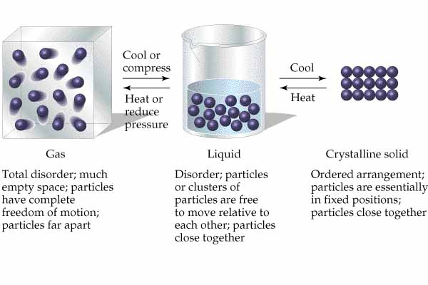
The particles of both liquids and solids vibrate because of the attractions of the particles for each other. Solid particles vibrate about a fixed point while liquid particles vibrate about a moving point.

Liquid particles have more freedom than solid particles (liquids can flow!). At the surface of a liquid it is possible for molecules of the liquid to escape from the liquid boundary and become vapor if they have enough energy to escape the attractive forces of the neighboring liquid molecules.

At any temperature there is a distribution of molecular speeds and kinetic energies as discussed earlier with gases. The liquid particles that have a certain minimum energy, the heat of vaporization, can escape from the surface of the liquid and we say evaporation has occurred. The graph below shows that as the temperature is increased, the fraction of liquid particles at the surface increases. The rate of evaporation increases with temperature.

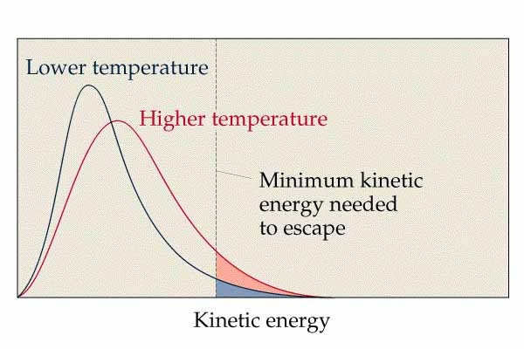

If we place a liquid in a closed container and connect the container to a manometer, we
will detect the pressure being exerted by the evaporating liquid. This pressure is called the vapor pressure.

Once a molecule moves from the liquid to the vapor state, there is a possibility that the vapor molecule may be recaptured if the vapor molecule collides with the liquid surface. Inside our closed container, two processes are taking place-evaporation and condensation- which are reverse processes. Eventually the rate of evaporation and the rate of condensation will become equal. We will then have reached a state of dynamic equilibrium.

The double arrows used in the equation indicate that the process is reversible. It is important to remember that a state of equilibrium will always be reached when a reversible change is taking place. When equilibrium is attained in the system, the vapor pressure will remain constant even though both processes, evaporation and condensation, are occurring.

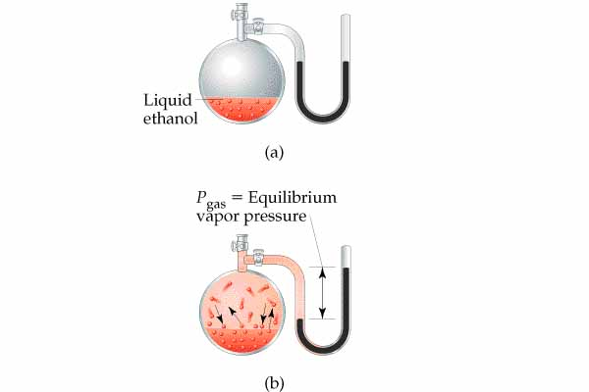

The equilibrium vapor pressure value depends on the temperature. As the temperature of the liquid increases, the vapor pressure will increase exponentially. The graph below shows how the vapor pressures of several liquids vary with temperature.

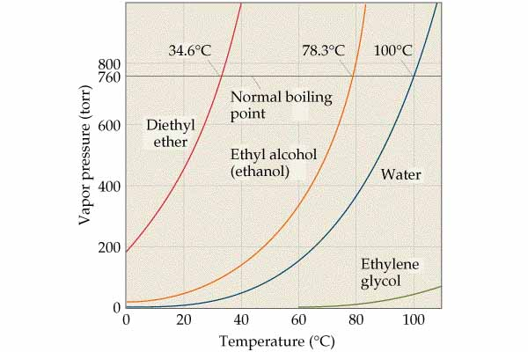

When the vapor pressure of the liquid becomes equal to the atmospheric pressure pressing down on the liquid surface, the liquid will begin boiling. Evaporation only takes place on the surface of a liquid and it occurs at all temperatures. Boiling only occurs at one specific temperature (dependent on the atmospheric pressure) and takes place throughout the volume of the liquid. Notice in the diagram that the boiling points of different liquids are different due to the differences in the strength of the intermolecular forces holding the liquid molecules together.
Solids have particles that are very close to each other with very restricted motions. In crystalline solids the particles are ordered in well defined arrangements. The repeating unit of a solid is called a unit cell. The unit cells stack on each other producing a crystal lattice as shown in the diagram below.

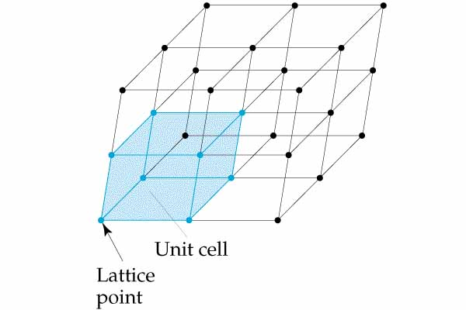

Solids can evaporate also! The process is usually called sublimation when a solid changes directly into a gas without passing through the liquid state. Dry ice, solid carbon dioxide, is the most common example of a substance that sublimes rapidly at room temperature. We can also plot a graph of the vapor pressure of a solid versus the temperature. We will reach a point where the vapor pressure of the solid equals the vapor pressure of the liquid. At this point the solid and liquid are in equilibrium with each other. This temperature is called the melting point of the solid or the freezing point of the liquid. All of this information about the relationship between vapor pressure and temperature can be pictured on a phase diagram.

The general form of a phase diagram for a substance that exhibits three phases is shown below. The diagram contains three important curves, each of which represents the conditions of temperature and pressure at which the various phases can coexist at equilibrium.

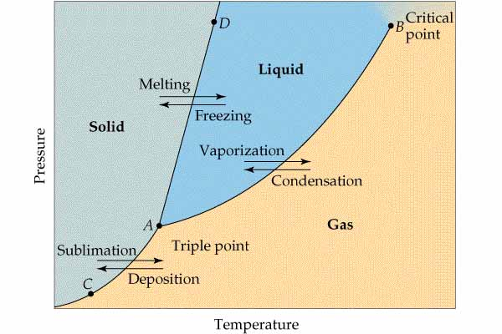

The line from A to B is the vapor pressure curve of the liquid. It represents the equilibrium between the liquid and gas phases. The point on the curve where the pressure is 1 atm is the normal boiling point. The vapor pressure curve ends at the critical point (B). Beyond the critical point the liquid and gas phases are indistinguishable.

The line AC represents the variation in the vapor pressure of the solid as it sublimes at different temperatures.

The line from A through D represents the change in melting point of the solid with increasing pressure. This line usually slopes slightly to the right because the solid state for most substances is denser than the liquid.

Point A where the three curves intersect is called the triple point. All three phases are present in equilibrium at this temperature and pressure.

A phase diagram can be used to predict what state(s) are present at any temperature and pressure. Below are the phase diagrams for water and carbon dioxide.

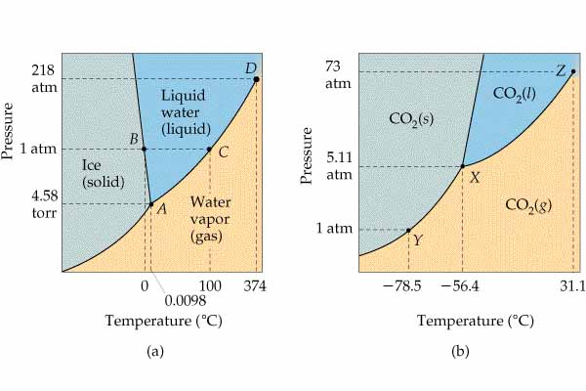

Notice that the solid-liquid equilibrium line for water slopes to the left. This is because the liquid state is more dense than the solid state. This is due to the rather open arrangement of water molecules in ice due to the formation of hydrogen bonds. This open structure collapses as ice melts, allowing the molecules to actually move closer together as water is warmed from 0 to 4 C. Notice also the triple point of water is at a much lower pressure than that of carbon dioxide. The liquid state of carbon dioxide cannot exist unless the pressure is above 5.11 atmospheres which explain why dry ice sublimes in an open container.

How much energy does it take for a phase change to occur? The graph below shows how the temperature of water changes as energy is added.

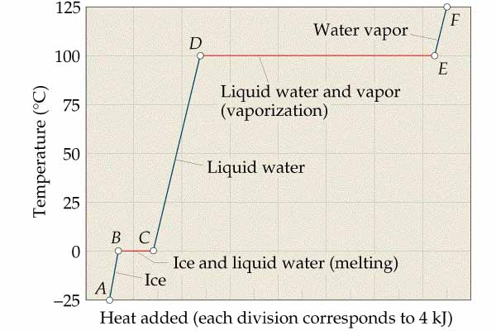

Notice that the heating curve has two regions which are plateaus. Heat energy is being added but the temperature is not increasing! The energy being added during a phase change increases the potential energy of the water because the molecules are being pulled away from each other (hydrogen bonds are being broken). Remember that potential energy increases when molecules which are attracted to each other are forced apart. A thermometer does NOT sense potential energy so the temperature does not increase even though the energy of the water is increasing.

How can we calculate the energy needed to melt a solid or boil a liquid? We cannot use the formula q=mc∆T because there is NO temperature change during a phase change. During a phase change the energy will depend on the mass, m, of the substance and the strength of the forces of attraction between the particles. The energy needed to melt one gram of a solid at its melting point is called the heat of fusion, H_{f}. The energy needed to boil one gram of a liquid at its boiling point is called the heat of vaporization, H_{v}. Melting and boiling are endothermic processes. The reverse processes, freezing and condensing, are exothermic. In the portions of the graph where the temperature is changing, the equation q=mc∆T can be used. The specific heat capacity, c, of the three states is different. Be sure to practice this type of calculation which involves multiple steps. The heating curve is useful to determine how many steps are involved in the process.

In summary, if we need to calculate the heat needed to heat a solid we use
. To melt the solid we use . To heat the liquid we use . To boil the liquid we use . To heat the gas we use .

HNRS Chemistry Name________________________________
HW 5-6 Period_____ Date______________________
Solids, Liquids, and Phase Diagrams

- Distinguish between solids and liquids in terms of the motions of the particles that make up solids and liquids.

- Distinguish between solids and liquids in terms of the arrangement of the particles that make up solids and liquids.

- Define the vapor pressure of a liquid.

- Explain the nature of the dynamic equilibrium that exists between a liquid and its vapor in a sealed container.

Questions 5 and 6 refer to the vapor pressure curves shown below.

- What is the normal boiling point of ethyl alcohol according to the vapor pressure curve shown above?

- What would be the boiling point of water at a pressure of 400 torr (mm Hg)?

Questions 7-10 refer to the phase diagrams of water and carbon dioxide shown below.
- As the pressure increases, the freezing point of water ________ and the freezing point of carbon dioxide ________.

- When ice is heated from -80°C to 50°C at a pressure of 1 atm, _______(phase change) takes place. When dry ice is heated from -80°C to 50°C at a pressure of 1 atm, _______ (phase change) takes place.

- The critical temperature of water is _______ (>, <, equal to) the critical temperature of carbon dioxide because the attractive forces in water are ________ (>, <, equal to) the attractive forces in carbon dioxide.

- Explain how to convert dry ice into liquid carbon dioxide.

Chemistry Name_____________________________
HW 5-7 Period ___ Date____________________
Energy Changes during Phase Changes

The graph below is a heating curve for 100.0 grams of a substance. Use the heating curve to answer the questions below.

- What is the melting point of the solid?

- What is the boiling point of the liquid?

- What is the specific heat capacity of the solid in?

- What is the heat of fusion of the solid in?

- What is the specific heat capacity of the liquid in?
- What is the heat of vaporization of the liquid?

- What is the specific heat capacity of the gas in?

Using the constants determined above, calculate the following.

- How many kJ of heat energy would be needed to take 50.0 g of the solid at -40°C and heat it to 0°C?

- How many kJ of heat energy would be released if 25.0 g of the gas at 90°C is cooled to 50°C?

- Why is the heat of fusion less than the heat of vaporization?

