Chemistry
Lecture 5-3
Applications of PV = nRT / Other Gas Laws

Applications of PV=nRT

The ideal gas law can be rearranged to give several useful quantities. Frequently the chemist would like to know the density of a particular gas. Measuring the volume of a gas is easy but a mass measurement can be difficult! The derivation below suggests that the density of a gas can be determined from a measure of just the pressure and temperature, two easily measured quantities!

We can see that the density can be calculated from only the pressure and temperature for a known gas (MM must be know). The equation also points out that gas density is directly related to pressure and molecular mass and inversely related to temperature.

If we solve this substituted form of PV=nRT for molecular mass, MM, we find that the molecular mass can be calculated if we can measure the mass, volume, pressure, and temperature of the gas.

In our next lab we will use this form of the ideal gas equation to calculate the molecular mass, in g/mol, of the gas butane which is commonly used as the fuel in pocket lighters. We will need to use a precise balance capable of measuring the very small mass of the gas collected.

Last quarter in Unit 3 on stoichiometry we used the molar volume at STP (22.4L/mol) to convert the volume of a gas in liters to moles. We no longer have to restrict gas stoichiometry to problems at STP because the ideal gas law will allow us to find the number of moles gas at any set of conditions.

Given the temperature, pressure, and volume of a gas, we can use this equation to calculate the moles of gas.

Dalton’s Law of Partial Pressures (Pulled from Lecture 5-3)
A single container can hold a mixture of gases. What determines the total pressure in a mixture of gases and what contribution will each gas in the mixture make toward the total pressure? These questions are answered by Dalton’s Law of Partial Pressures. The partial pressure of an individual gas is the pressure the gas would exert if it were alone in the container. When chemists collect gases that are not soluble in water by water displacement, the collected gas is “wet” because water vapor will also be contained in the space in which the trapped gas is confined.

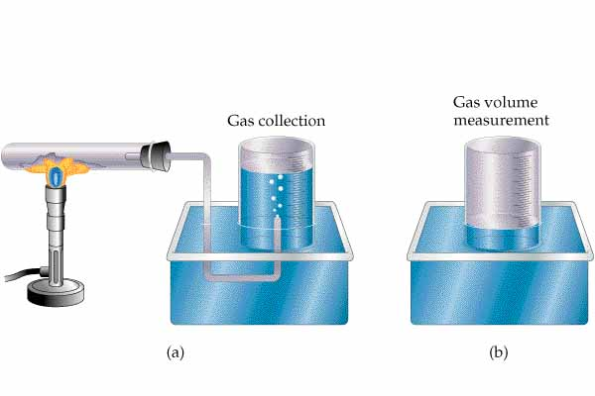
The trapped gas in the diagram to the left is “wet” because water vapor will also be trapped in the container. What pressure would the “dry” gas exert?
To find the pressure the collected gas would exert if it were alone in the container, we will call upon Dalton’s Law of Partial Pressures. Notice here that we are assuming that the volume of the collected gas would be the same if dry or wet!

Dalton’s Law states that the total pressure in a mixture of gases is simply the sum of the partial pressures of the individual gases. This law assumes that the gases in the mixture do not hinder or enhance the ability of any gas to exert pressure. In other words, each gas would exert the same amount of pressure if it were alone in the container.

We can look up the vapor pressure of water at any temperature in
reference manuals. We can then find the pressure of the collected
gas by merely subtracting the water vapor pressure from the total pressure which is measured in the lab.

What determines the partial pressure of a gas in a mixture? Since all gases in the mixture have the same volume and temperature, only the number of moles of the gas can make a difference. The partial pressure of a gas is directly related to the number of moles of each component gas.

Graham’s Law of Effusion

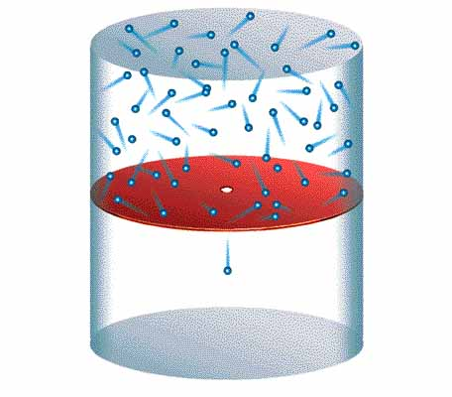
Effusion is the process where a gas under pressure is allowed to escape through a small opening into an evacuated space. Diffusion is the process whereby a gas spreads out to occupy the space around it. Graham’s Law applies to effusion but approximates the rates of diffusion also.

What determines the rate of effusion through the small opening when a mixture of gases is present in the top compartment?
Logically we would expect faster moving gas molecules to escape more frequently. How does the speed of the molecules differ with mass?

This second equation implies that the speed or velocity of the molecules depends only on the temperature (KEαT) and the mass of the molecule.
The speed of the molecules is inversely related to the square root of the molecular mass. This is called Graham’s Law of Effusion.

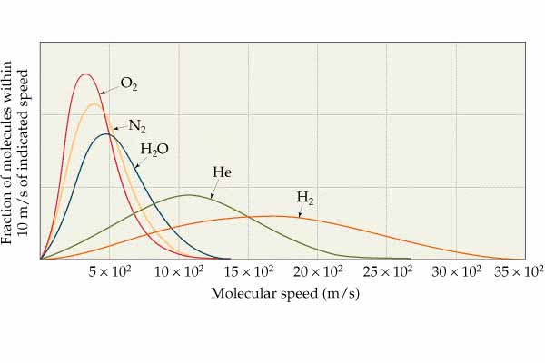
The graph above shows how the average speeds of molecules at the same temperature vary with the mass of the molecule. Graham’s Law can be expressed in equation form as shown below.

This equation gives the ratio of the rates (r) of effusion of two gases.
The rates only depend upon the velocities of the two gases which is inversely related to the square root of the molecular masses of the gases.

Real vs. Ideal Gas Behavior

Ideal gases are point masses with no attractive forces. Real gases are made up of molecules that do have a volume (not points!) and real gas molecules DO attract each other. Real gases behave much like ideal gases if the molecules are far apart (low pressure) and are moving fast (high temperature). At low temperatures and high pressures the gas laws based on the properties of an ideal gas fail to make accurate predictions. The graph below shows the behavior of one mole of real gases at large pressures. For an ideal gas the graph will be a horizontal line if the number of moles is held constant at one mole (n=PV/RT). At high pressures this ratio is less than

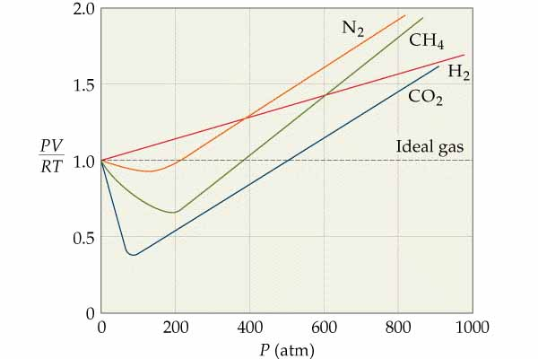

one due to the attractive forces decreasing the pressure predicted by the ideal gas law. At very high pressures the ratio is larger than one due to the fact that the molecules are taking up space and the volume of the container must be larger than predicted by the ideal gas law.

Chemistry Name____________________________
HW 5-4 Period_____ Date__________________
Applications of PV=nRT

- What is the density of O₂ gas at STP?

- What is the density of O₂ gas at a pressure of 2.00 atm and a temperature of 273°C?

- What is the molecular mass of a gas if 2.889 g of the gas has a volume of 936 mL at 31°C and 735 mm Hg?

- The safety air bags in cars are inflated by nitrogen gas generated by the rapid decomposition of sodium azide, NaN₃:

If an air bag has a volume of 36L and is to be filled with nitrogen gas at a pressure of 1.15 atmospheres at a temperature of 26.0°C, how many grams of NaN₃ must be decomposed?

- In the first step of an industrial process for making nitric acid, ammonia reacts with oxygen in the presence of a suitable catalyst to form nitric oxide and water vapor.

How many liters of NH₃ gas at 850°C and 5.00 atm are required to react with 16.0 g of O₂ in this reaction?

Chemistry Name___________________________________
HW 5-5 Period_____ Date_______________________
Dalton’s Law/Graham’s Law

- How much faster do hydrogen molecules effuse than oxygen molecules at the same temperature?

- An unknown elemental gas composed of diatomic molecules effuses at a rate that is 0.355 times that of O₂ at the same temperature. Determine the identity of the unknown gas.

- A gaseous mixture made form 6.00 g of O₂ and 9.00g of CH₄ is placed in a 15.0L vessel at 0°C. What is the partial pressure of each gas and the total pressure in the container?

- Oxygen gas is collected by water displacement. The pressure of the wet gas is 765 mm Hg. The vapor pressure of water at this temperature is 25 mm Hg. What is the pressure of the dry gas?

- A 2.00L container of oxygen gas has a pressure of 50 kPa at room temperature. An 8.00L container of neon gas has a pressure of 400 kPa at room temperature. What would be the total pressure is both gases were moved to a 4.00L container at room temperature?

