Chemistry
Lecture 5-2
Gas Laws

In this lecture we are going to study how the variables that we use to describe gases (P,V,T,and n) are related to each other. That stuff we learned in Unit 2 about direct and inverse variation will pay big dividends!

Charles’s Law
Charles’s Law describes the relationship between the volume of a fixed amount of gas at constant pressure and the Kelvin temperature. Under these conditions the volume is directly related to the Kelvin temperature.

V α T_{K} (P, n both constant)

This means that if the Kelvin temperature doubles, the volume of the gas will double. A graph of volume vs. Kelvin temperature will yield a straight line. If we plot the volume vs. the Celsius temperature, the straight line will cross the x-axis at the coldest possible temperature, absolute zero, or -273 ºC as shown in the graph below.

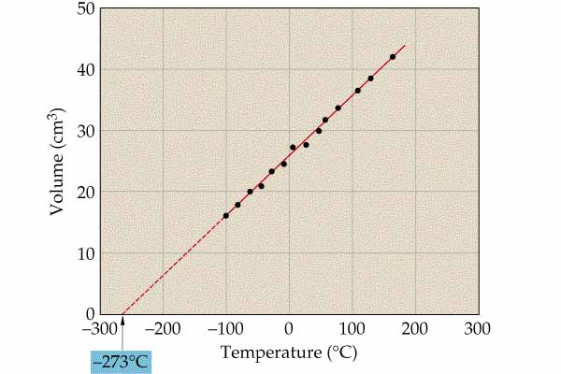
Since V is directly related to T, we know that V/T must be a constant, k. This constant depends on the pressure and amount of gas (moles).

V/T =k

We can write a proportion to express this constancy.

Charles’s Law is easily explained by the KMT. When a gas is heated, the molecules move faster and make more forceful collisions with the container walls. If the pressure is to remain constant, the container must get larger. The container will increase in volume until the extra distances the molecules have to move to make collisions compensates for the increase in the number and force of the collisions due to the greater speeds.

Boyle’s Law

Boyle’s Law states that the volume of a gas is inversely related to the pressure if the temperature and amount of gas are constant.

(T, n constant)

This means that if the pressure on a gas doubles, the volume will halve. If we plot volume vs. pressure, the graph will be a hyperbola since this is an inverse relationship.

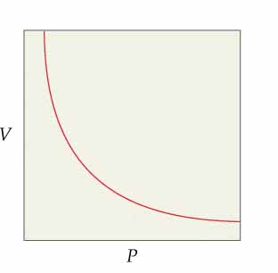

Since P and V are inversely related, the product of P and V must remain constant.

PV = constant = k

This constant depends on the temperature and amount of gas.

We can write a proportion based on this constant value for k.

Again the KMT can explain Boyle’s Law. As the volume of a gas increases, the molecules must move farther to make collisions with the walls of the container. Since there speeds must remain constant (temperature does not change), fewer collisions will be made in the larger container so the pressure will drop.

Gay-Lussac’s Law

Gay-Lussac’s Law states that the pressure a gas exerts is directly related to the Kelvin temperature for a fixed amount of gas at constant volume.

P α T (V, n constant)

This implies that a graph of P vs. T would be linear. The proportion below also indicates the direct relationship.

Can you explain this law using the KMT?

Avogadro’s Law

Avogadro’s Law describes the relationship between the number of moles of gas, n, and the volume of the gas at constant pressure and temperature. The law states that the volume of a gas is directly related to the number of moles if the temperature and pressure are constant.

V α n (P, T constant)

The constant ratio of V/n depends on P and T. The standard temperature for measuring gas volumes is 0ºC (273 K) and the standard pressure is one atmosphere. These conditions are called STP (standard temperature and pressure). At STP the molar volume ratio is 22.4 L/mole. We use this relationship in Unit 3 in the mole mall. The constant will not be 22.4 at other conditions.

Can you explain Avogadro’s Law using the KMT?

The gas laws can be combined to predict the volume of a gas if more than one variable is changed. For example, we can write a relationship that combines Charles’s Law and Boyle’s Law for the situation where both the temperature and pressure of the gas are changing.

This is called the combined gas law and is particularly convenient when determining the volume of a gas at standard conditions when the volume is measured at nonstandard conditions.

Ideal Gas Law

The ideal gas law combines all of the gas laws!

R is called the ideal gas constant. In our next lab we will determine an experimental value for the constant. The numerical value of R depends on the units we choose to measure the volume and pressure of the gas. We have no choice for the temperature unit or for the units of n. The temperature must be in Kelvins and the value of n must be in moles. We know from previous studies that one mole of a gas will have a volume of 22.4 L at STP (273 K and 1atm.). Using these values we can calculate a value of R.

Chemistry Name_________________________________
HW 5-2 Period_____ Date_______________________
Gas Laws

- Write the proportion that identifies each of the following gas laws.
- Charles Law
- Boyle’s Law
- Gay-Lussac’s Law
- Avogadro’s Law

- The volume of a gas is 5.00 L at a temperature of 50.0°C. What will be the volume of the gas at 100.0°C?

- The volume of a gas is 10.0L at -100.0°C. To what Celsius temperature will the gas have to be heated so that the volume will be 20.0L?

- The volume of a gas is 5.00L when the gas pressure is 1.00 atm. What will be the volume of the gas when the pressure is reduced to 0.500 atm.?

- The volume of a gas is 10.0L at a pressure of 325 mm Hg. What pressure in kPa will be needed to increase the volume to 20.0L?

- The molar volume of a gas is 20.0 L/mol at a certain temperature and pressure. What is the volume of 0.250 mol of the gas under these conditions?

- The pressure inside a container of gas is 2.50 atm. at 0°C. What will the pressure be inside the container if the temperature is raised to 273°C?

- The volume of a gas is 5.00 L at STP. What will be the volume of the gas at 100.0°C and a pressure of 50.0 kPa?

- Calculate the STP volume of a gas if the volume of the gas is 750 mL at -50.0°C and 0.500 atm.

- A container holds 2.00 moles of gas at 27.0°C and exerts a pressure of 1.00 atm. If an additional 3.00 moles of gas is added to the container and the mixture of gases is heated to 127°C, what will be the pressure of the mixture of gases?

HNRS Chemistry Name_______________________________
HW 5-3 Period ______ Date_______________
Ideal Gas Equation (PV=nRT)

- What is the volume, in liters, of 3.25 mol of O₂ gas at 27°C and 375 mm Hg?

- What pressure, in kPa, does 14.0 g of N₂ gas exert in a 5.00L container at -100.0°C?

- What is the Celsius temperature of a gas if 5.00 moles of the gas exerts a pressure of 2.5 atm in a 10.0 L container?

- How many grams of chlorine gas (Cl₂) is in a 4.50 L container if the temperature is 127°C and the pressure is 555 mm Hg?

- A child has a lung capacity of 2.20 L. How many grams of air do her lungs hold at a pressure of 102 kPa and a normal body temperature of 37°C? Air is a mixture, but you may assume an average molar mass of 29 g/mol for air because air is about 20% O₂ (molar mass 32) and 80% N₂ (molar mass 28).

