Chemistry
Lecture 5-1
Kinetic Molecular Theory (KMT)

We spent the first semester studying the structure of the particles that make up matter (atoms, ions, and molecules). Now we are going to look at how these particles interact with each other in the solid, liquid, and gaseous states.

The kinetic molecular theory is a theory that explains the motion of gas molecules. This theory explains why gases exert pressure and why gases expand when heated. The term “kinetic” implies motion. The kinetic energy of a particle depends both on its mass and velocity (KE=1/2 mv²). The KMT has several basic simplifying assumptions that you need to MEMORIZE. The basic assumptions of the KMT are listed below.

- Gases are composed of particles (molecules) that are in constant random motion.
- The volume of the actual gas molecules is negligible when compared to the total volume in which the gas is contained.
- Attractive and repulsive forces between the gas molecules are negligible.
- Collisions between gas molecules are elastic (KE is conserved).
- The average KE of the gas molecules only depends on temperature. The average KE is directly related to the Kelvin temperature (K=C+273).

The assumptions made above describe a hypothetical gas called an ideal gas. Ideal gases do NOT exist but assuming these properties makes the mathematics needed to describe gas behavior very simple. Later we will deal with the deviations that occur when real gases are studied.

There are two ways we can sense the movements of the gas molecules in a container that do not rely on us being able to see the molecules or having to know exactly what each molecule is doing. We can easily measure the temperature of a gas and the pressure the gas exerts on the walls of the container. These simple measurements tell us something about the movement of the molecules.

The temperature of a gas tells us the average KE of the gas molecules. We do NOT know the total energy of all the molecules when we measure the temperature. If we could do this, then thermometers would be marked off in energy units like joules or calories. Temperature does NOT measure heat energy. Temperature only measures the average KE of the molecules. The thermometer does not see potential energy at all! The potential energy stored up in a tank of gasoline is large but a thermometer will not detect this potential energy. How is temperature related to heat? Temperature can only be used to predict the direction of heat flow. Heat will always flow from an object at a higher temperature to another object at a lower temperature.

How do the kinetic energies of the different molecules in the same container vary at one particular temperature? Because the molecules collide with each other, some of the molecules will be moving faster than others. There will be a distribution of speeds from slower moving molecules to faster moving molecules. The diagram below shows how the speeds (designated by μ) will be spread out over a range. The majority of the molecules will have a speed close to the average speed. If the temperature is increased, the average speed will increase and the range of speeds will also spread out.

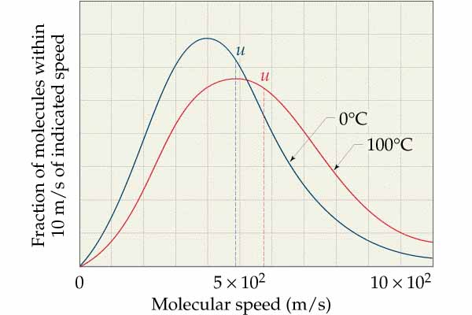
The blue line shows the distribution of speeds at O C and the red line shows the distribution at 100 C. The average speed increases with temperature and the range of speeds also increases at higher temperatures.
Thank goodness we can just work with the averages and make good predictions!

The collisions of gas molecules with the walls of the container create pressure. Pressure is defined as force/area (P=F/A). The pressure a gas exerts is directly related to the number of particles, n (in moles), in the container. The pressure also depends on how frequently the gas molecules collide with the container walls. This collision frequency depends on the size of the container (inverse relationship), the speed of the molecules (direct relationship), and the momentum (speed and mass) of the molecules (direct relationship). How can we measure this pressure without counting the molecules and measuring their speeds (an impossible task!)?

A device called a manometer is used to easily measure gas pressure. A manometer is just a U-shaped piece of tubing filled with some liquid. The manometer can be connected to a container filled with a gas. The gas will push down on the liquid surface because of the collisions of the gas molecules with the liquid surface. The other “arm” of the manometer can be open or closed. An open-arm manometer measures the difference in pressure between the trapped gas and the pressure of the air in the room (atmospheric pressure). A closed-arm manometer has a vacuum on the closed side so there is nothing to push back against the confined gas. An open-arm manometer measures the relative pressure of the gas and a closed arm manometer measures the absolute pressure. The diagram below shows both open and closed-armed manometers. Notice that the liquid level will always be lower on the arm of the manometer with the greater pressure. In our next lab we will make a simple open-arm manometer using some plastic tubing and some water. We will measure the pressure of several gases.

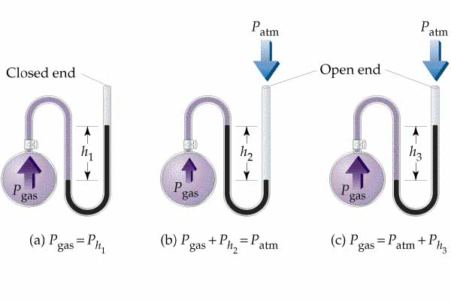

What units can be used to express pressure? The metric unit of force is the newton (N) and the unit of area would be square meters (m²). However, we do NOT know the force of all these collisions nor do we want to have to measure the surface areas of the containers confining the gases. A practical pressure unit would simply be the height of the liquid column produced when the confined gas is attached to a manometer. Manometers are usually filled with the liquid mercury because of its large density so pressure could be measured in millimeters (NOT milliliters!) of mercury (mm Hg). We can also express the pressure of a gas by comparing it to the pressure of the air (atmosphere). On an average day at sea level a barometer (instrument used to measure atmospheric pressure) reads 760 mm Hg. This is called one atmosphere (atm.) of pressure. The metric unit of pressure (N/m²) is called a pascal (Pa) and is very small. It takes 101.325 kPa to equal one atmosphere. In case you are not confused by now with all these units (fat chance!), you can remember that one atmosphere is 14.7 psi (pounds per square inch). Do not try to memorize all these units. Just be able to make conversions if I give you the conversion factors. The standard pressure (SP) is one atmosphere.

Notice that with simple devices like thermometers and manometers (pressure gauges) we can measure the movements of all those tiny little molecules that we cannot see or count! Wow!

Chemistry Name______________________________
HW 5-1 Period ______ Date____________________
Kinetic Molecular Theory

- What are the basic assumptions of the kinetic molecular theory (KMT)?

- Identify each variable and its units for the equation shown below.

- How can you easily determine the average kinetic energy of a group of gas molecules?

- Convert a temperature of -100 °C to Kelvin.

- Identify each variable and its units for the equation below.

- Convert a pressure of 1.50 atmospheres to mm of Hg.

- Convert a pressure of 375 mm of Hg to kilopascals.

- What factors determine the pressure exerted by a confined gas?

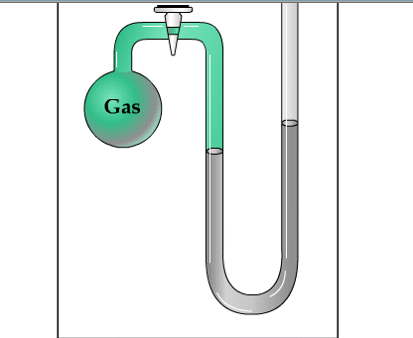

- If the difference in the Hg levels in the manometer shown above is 55 mm Hg and the barometer reads 728 mm Hg, what is the pressure of the confined gas? Assume the right arm of the manometer is open.

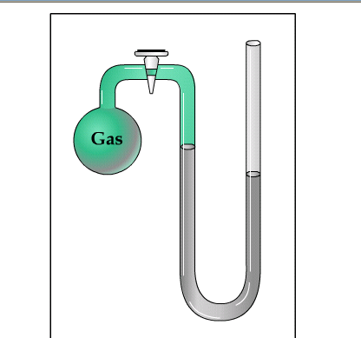
10. What is the pressure of the confined gas if the difference in the Hg levels is 45 mm Hg and the atmospheric pressure is 758 mm Hg?

