Article of the Week #1
How Do Vaccines Work? (1290L)

Instructions: COMPLETE ALL QUESTIONS AND MARGIN NOTES using the CLOSE reading strategies practiced in class. This requires reading of the article three times.

Step 1: Skim the article using these symbols as you read:
(+) agree, (-) disagree, (*) important, (!) surprising, (?) wondering
Step 2: Number the paragraphs. Read the article carefully and make notes in the margin.
Notes should include:
- Comments that show that you understand the article. (A summary or statement of the main idea of important sections may serve this purpose.)
- Questions you have that show what you are wondering about as you read.
- Notes that differentiate between fact and opinion.
- Observations about how the writer’s strategies (organization, word choice, perspective, support) and choices affect the article.
Step 3: A final quick read noting anything you may have missed during the first two reads.

Your margin notes are part of your score for this assessment. Answer the questions carefully in complete sentences unless otherwise instructed.

Student ____________________________Class Period__________________

Notes on my thoughts, reactions and questions as I read:

How do vaccines work?
Let’s Begin…The first ever vaccine was created when Edward Jenner, an English physician and scientist, successfully injected small amounts of a cowpox virus into a young boy to protect him from the related (and deadly) smallpox virus. But how does this seemingly counterintuitive process work? Kelwalin Dhanasarnsombut details the science behind vaccines.
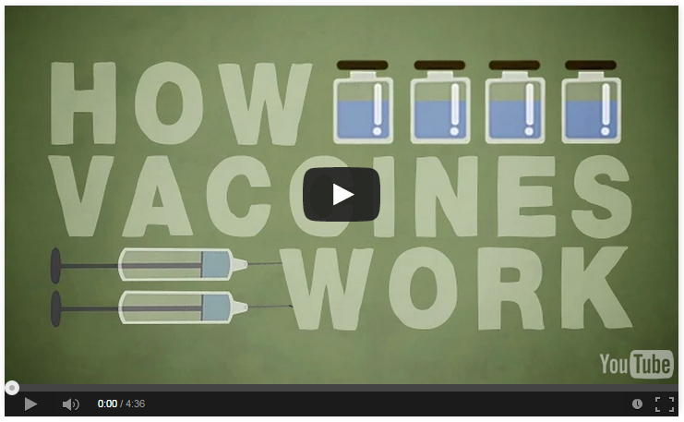

https://www.youtube.com/watch?v=rb7TVW77ZCs

Transcription of TED Talk:

In 1796, the scientist Edward Jenner injected material from a cow pox virus into an eight-year-old boy with a hunch that this would provide the protection needed to save people from deadly outbreaks of the related smallpox virus. It was a success. The eight-year-old was inoculated against the disease, and this become the first every vaccine. But why did it work?

To understand how vaccines function, we need to know how the immune system defends us against contagious diseases in the first place. When foreign microbes invade us, the immune system triggers a series of responses in an attempt to identify and remove them from our bodies. The signs that this immune response is working are the coughing, sneezing, inflammation, and fever we experience which work to trap, deter, and rid the body of threatening things, like bacteria. These innate immune responses also trigger our second line of defense called adaptive immunity.

Special cells called B cells and T cells are recruited to fight microbes and also record information about them creating a memory of what the invaders look like and how best to fight them. This know-how becomes handy if the same pathogen invades the body again. But despite this smart response, there’s still a risk involved. The body takes time to learn how to respond to pathogens and to build up these defenses. And even then, if a body is too weak or young to fight back when it’s invaded, it might face very serious risk if the pathogen is particularly severe. But what if we could prepare the body’s immune response, readying it before someone even got ill?

This is where vaccines come in. Using the same principles that the body uses to defend itself, scientists use vaccines to trigger the body’s adaptive immune system without exposing humans to the full strength disease. This has resulted in many vaccines, which each work uniquely, separated into many different types.

First, we have attenuated vaccines. These are made of the pathogen itself but a much weaker and tamer version. Next, we have inactive vaccines, in which the pathogens have been killed. The weakening and inactivation in both types of vaccine ensures that pathogens don’t develop into the full blown disease. But just like a disease, they trigger an immune response, teaching the body to recognize an attack by making a profile of pathogens in preparation. The downside is that live attenuated vaccines can be difficult to make and because they’re live and quite powerful, people with weaker immune systems can’t have them, while inactive vaccines don’t create long-lasting immunity.

Another type, the subunit vaccine, is only made from one part of the pathogen, called an antigen, the ingredient that actually triggers the immune response. By even further isolating specific components of antigens, like proteins or polysaccharides, these vaccines can prompt specific responses.

Scientists are now building a while new range of vaccines called DNA vaccines. For this variety, they isolate the very genes that make the specific antigens the body needs to trigger its immune response to specific pathogens. When injected into the human body, those genes instruct cells in the body to make the antigens. This causes a stronger immune response and prepares the body for any future threats, and because the vaccine only includes specific genetic material, it doesn’t contain any other ingredients from the rest of the pathogen that could develop into the disease and harm the patient. If these vaccines become a success, we might be able to build more effective treatments for invasive pathogens in years to come.

Just like Edward Jenner’s amazing discovery, spurred on modern medicine all those decades ago, continuing the development of vaccines might even allow us to treat diseases like HIV, malaria, or Ebola, one day.

Article of the Week #1
How Do Vaccines Work? (1290L)

Notes on my thoughts, reactions and questions as I read:

Article of the Week #1
How Do Vaccines Work? (1290L)
Comprehension questions – answers may be in phrases.

- Edward Jenner created a vaccine against smallpox by injecting patients with material from what disease?

- What is the purpose of the author’s use of the question “But why did it work?” early in the TED Talk?

- Define contagious as used in the article.

- What is the main advantage of the live attenuated disease?

- Define principles as used in the text.
7/8.RI.4,5,6

7/8.RI.1,2,3,4,5

2. Answer each question in one or more complete sentences.

What is the function of an innate immune response?

Which of the vaccine types appears to be in the research phase as of right now? How were you able to infer this?

Explain this statement: “Vaccines do not only protect against those who get vaccinated, but others as well.”

7/8.RI.1

Of the

Article of the Week #1
How Do Vaccines Work? (1290L)

3. What are the advantages and disadvantages of using a TED Talk versus a written article? Given a choice, which medium would you prefer? Explain.

7/8.RI.7

(

4. Create a dialogue between two parents. Parent 1 wishes to opt out of vaccinations for their children while parent 2 believes vaccinations are essential for the health of his/her children as well as the health of other people. The majority of the responses should cite directly from the text and/or previous texts reviewed in class. A minimum of 10 total responses is required.

7/8.RI.6

RI.2

