Heart Health: How Does Heart Rate Change with Exercise?

Abstract
Your heart starts beating before you are born and keeps right on going through your whole life. Over an average lifetime, the human heart beats more than 2.5 billion times. Keeping your heart healthy means eating right, not smoking, and getting regular exercise. Which of your favorite physical activities give your heart the best workout? Find out with this project!

Objective
The goal of this project is to measure your average heart rate during different types of activities.

Introduction
The human body has about 5.6 liters of blood, which the heart circulates about three times every minute (NOVA, 1997a). Your heart is constantly beating—even before birth!—to keep the blood circulating. The heart of an average 65-year-old person has contracted more than 2.5 billion times. That's a lot of heartbeats!
Experts on cardiac health tell us that the best way to keep our hearts healthy are a balanced diet, avoiding smoking, and regular exercise. Exercise that is good for your heart should elevate your heart rate. How much, for how long, and how often? The American Heart Association recommends that you do exercise that increases your heart rate to between 50 and 75% of your maximum heart rate (your maximum heart rate is 220 beats per minute, minus your age). They recommend getting at least 30 minutes of exercise on most days of the week (AHA, 2006).
What is your resting heart rate? What types of exercises work to elevate your heart rate? How do you feel when your heart is working at 50% of its maximum rate? How about when it is working at 75% of its maximum rate? This project will help you answer all of these questions, and help you find fun activities that are good for your heart.

Terms, Concepts, and Questions to Start Background Research
To do this project, you should do research that enables you to understand the following terms and concepts:

- pulse,
- maximum heart rate,
- target heart rate zone,
- aerobic exercise,
- anaerobic exercise.
• the cardiovascular system.

Questions (to be answered at the end of the activity)
- What are some examples of activities that provide aerobic exercise?
- What are some examples of activities that provide anaerobic exercise?
- What is the average maximum heart rate for someone your age?
- What is the range recommended for heart rate during exercise?
    - How much exercise does your body need each week for good
    - cardiovascular health?

Bibliography
- AHA, 2006. "Target Heart Rates," American Heart Association [accessed June 20, 2006] http://www.americanheart.org/presenter.jhtml?identifier=4736.
- This worksheet from the American Heart Association can help you evaluate your fitness level and make a plan for improvement: AHA, 2002. "How Fit Am I?" American Heart Association [accessed June 20, 2006] http://www.americanheart.org/downloadable/heart/102441247283957%20How%20Fit%20Am%20I%20(6-8)% 20.pdf.
- This NOVA website has information on how the heart works and amazing heart facts:
  - WGBH, 1997a. "Amazing Heart Facts," NOVA Online, WGBH, Boston [accessed June 20, 2006] ttp://www.pbs.org/wgbh/nova/heart/heartfacts.html.
  - WGBH, 1997b. "Map of the Human Heart," NOVA Online, WGBH, Boston [accessed June 20, 2006] http://www.pbs.org/wgbh/nova/heart/heartmap.html.
  - WGBH, 1997c. "Cut to the Heart," NOVA Online, WGBH, Boston [accessed June 20, 2006] http://www.pbs.org/wgbh/nova/heart/.
- This site has a Java applet you can use to make printable, color graphs of your data: NCES, 2006. "Create a Graph," National Center for Education Statistics, U.S. Dept. of Education [accessed June 20, 2006] http://nces.ed.gov/nceskids/createagraph/.
Materials and Equipment
To do this experiment you will need the following materials and equipment:

- clock with second hand (or a helper with a watch),
- comfortable exercise clothes,
- simple and fun exercise equipment, e.g.:
                - jump rope,
bicycle,
hula-hoop, etc.
- lab notebook,
- pencil,
- graph paper (or graphing program)

Experimental Procedure
Measuring Your Heart Rate
1. Use the first two fingers of one hand to feel your radial pulse on the opposite wrist (see Figure 1). You will find it on the "thumb side" of your wrist, just below the base of your hand. Practice finding your pulse until you can do it quickly. Note: don't use your thumb, because it has its own pulse, which could throw off your count.
Figure 1. The photo shows how to feel your radial pulse.
2. Your heart rate is the number of beats per minute, but you don't have to count for a full minute to get an accurate heart rate. Counting the number of beats in either 10 or 15 seconds is fine. Use the clock to time your count, and write down the number of beats you counted in your lab notebook. Then calculate the number of beats per minute to get your heart rate. If you counted for ten seconds what do you need to multiply by to get the number of beats per minute? How about if you counted for 15 seconds? That's it!
Activity and Heart Rate
- Do your background research and make sure that you are knowledgeable
about the terms, concepts, and questions, above.
- Measure your resting heart rate and record it in your lab notebook, along
with the date and time of the measurement. It's a good idea to do this several times, and at different times of day, so that you can get a reliable average. You'll also get an idea of the normal range of variation for your resting heart rate. Calculate the average and standard deviation for your resting heart rate. Calculate how many times your heart beats during a day, a month, and a year.
- You will be measuring your heart rate during different types of physical
activity. Choose activities that you enjoy doing or that you think would be good exercises. You can see some examples in the sample data table, below. See if you can predict the order of increasing heart rate for the activities.
- Before starting each activity, make sure to measure your resting heart rate.
Leave enough time between activities so that your heart rate returns to its normal resting level.
- Perform each activity for 15 minutes, measuring your heart rate at the
times indicated in the table (after 1, 2, 5, 10, and 15 minutes of activity).
- It may take more than one day to make measurements for all of the
activities you want to try, so be sure to plan ahead so that you have enough time to collect data.
- Make line graphs of heart rate vs. time for each activity. Use graph paper, a
spreadsheet program (like Excel), or Create a Graph. Compare the graphs.

Questions (to be answered at the end of the lab)
- Which activity increased your heart rate the most (highest peak)?
- Which activity increased your heart rate the fastest (greatest slope)?
- Which activities elevated your heart rate to the target zone for aerobic exercise (50–75% of maximum heart rate)?
- Do you notice any consistent patterns in your heart rate graphs?
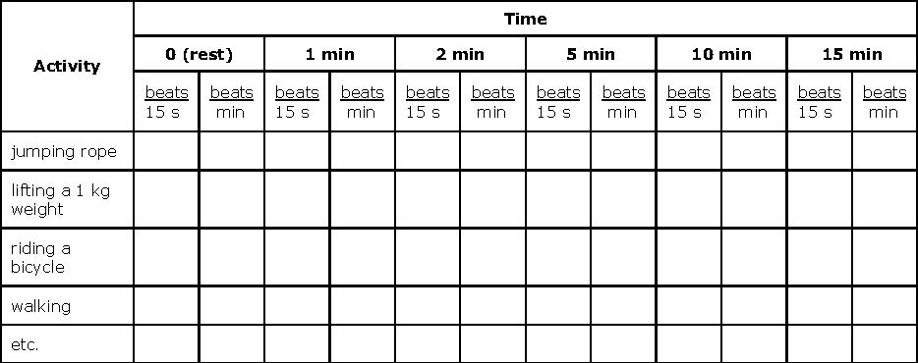

Credits
Andrew Olson, Ph.D., Science Buddies; Last edit date: 2011-10-26; 12:00:00
Lab Rubric

You must have a cover sheet that gives the following information: (8 points)
- Lab Title (Heart Rate Lab)
- Name
- Date
- Class Period

Terms Defined (6 Points)
¹Pulse, ²Maximum heart rate, ³Target heart rate zone, ⁴Aerobic exercise, ⁵Anaerobic exercise, ⁶Cardiovascular system

Your resting heart rate? (2 point)
Show your work

Your target heart rate range? (4 points)
Show your work

Completed Table (24 points)
This needs to be done in Exel

Completed graph (48 Points)
All 4 lines should be on same graph for comparison. Make the line graphs of heart rate (y-axis) vs. time (x-axis) for each activity.

Answer the following questions completely: (8 Points)
- Which activity increased your heart rate the most (highest peak)?
- Which activity increased your heart rate the fastest (greatest slope)?
- Which activities elevated your heart rate to the target zone for aerobic exercise (50-75% of MHR)?
- Do you notice any consistent patterns in your heart rate graphs?
- What are some examples of activities that provide aerobic exercise?
- What are some examples of activities that provide anaerobic exercise?
- What is the range recommended for heart rate during exercise?
- How much exercise does your body need each week for good cardiovascular health?

