Good Readers “Make Connections”
Using what I know (schema/prior knowledge) helps me understand what I am reading.
Text to Self
Something similar happened to me…
I remember when...
Text to Text
A book I read had a similar problem (character, setting)
This is similar to another book I read…..

Text to World
That reminds me of something I heard (saw, read) in the news…
Text to Media
That reminds me of something I heard (saw, read, listened to) in the media…
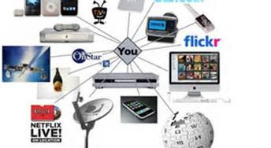
As you make connections during your reading, STOP and THINK about how they help you deepen your understanding of the text.

