Alfred Binet
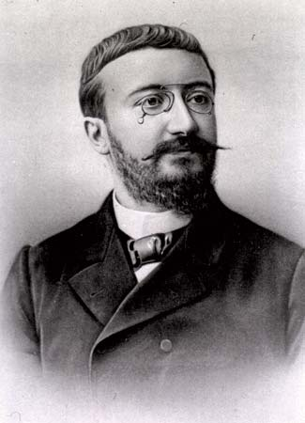
Testing/Individual Differences

Worked with Theodore Simon to devise the first modern intelligence test in 1905

Margaret Floy Washburn
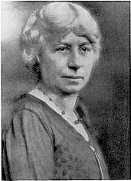
History and Approaches

The first woman to hold a Ph.D. in psychology (conferred in 1894)

Jean Piaget

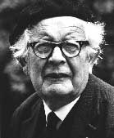

Developmental

Developed a four stage theory of cognitive (intellectual) development in children

Rene Descartes
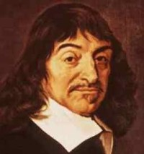
History and Approaches

Dualism- holds that reality is composed of two entities, mind and matter (body) with the mind being entirely distinct from the body

French philosopher-mathematician

Albert Bandura 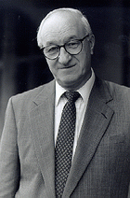

Learning

Stressed the importance of observation and imitation in learning and proposed a more social-learning approach.
*Bobo Doll

John B. Watson
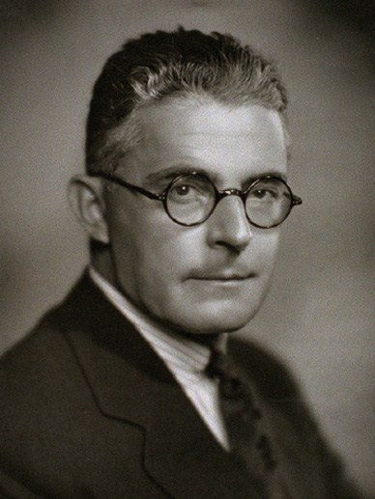

Behavioral

Behaviorism was founded with the publication of his influential article, “Psychology as the Behaviorist Views It”

*Nurture only
*Little Albert

Abraham Maslow 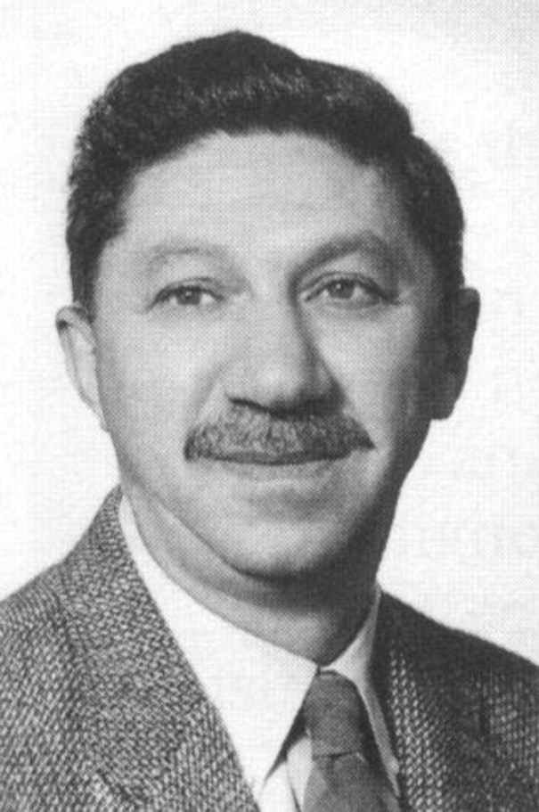

Motivation and Emotion

Humanistic psychologist; developed a “hierarchy of needs” that stressed the importance of positive growth and self-actualization

Hans Seyle 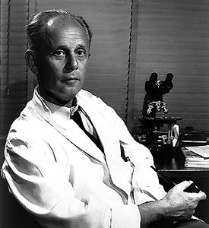

Motivation and Emotion

Developed the general adaptation syndrome (GAS) which is a three phase process for dealing with stress.

Paul Broca
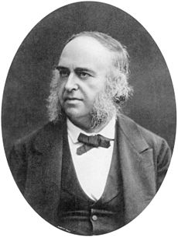

Biology

The French surgeon, proposed that the production of speech is controlled by the left side of the human brain in an area later named after him.

*Patient: Tan

Carl Rogers
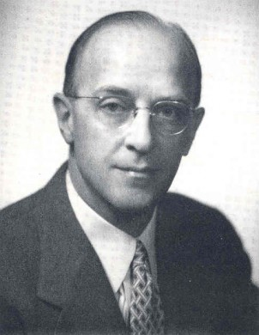

Treatment/ Personality

Developed a form of therapy called client-centered therapy, which stresses humanistic ideas such as positive personal growth.

Edward Thorndike
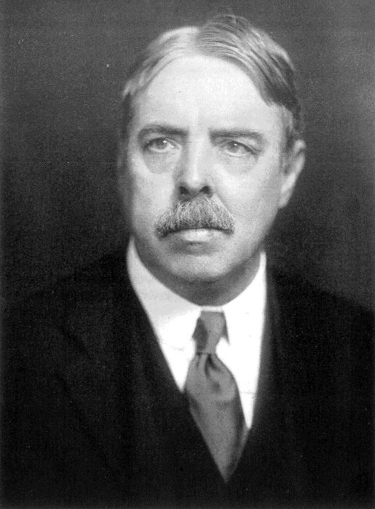

Learning

American psychologist who discovered the “law of effect” through his experiments with cats in a “puzzle box”.

Lawrence Kohlberg
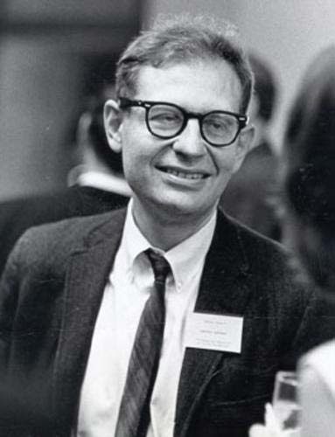
Development
al

Developed a theory of moral development including preconvention, conventional, and post conventional morality or reasoning.

Charles Darwin
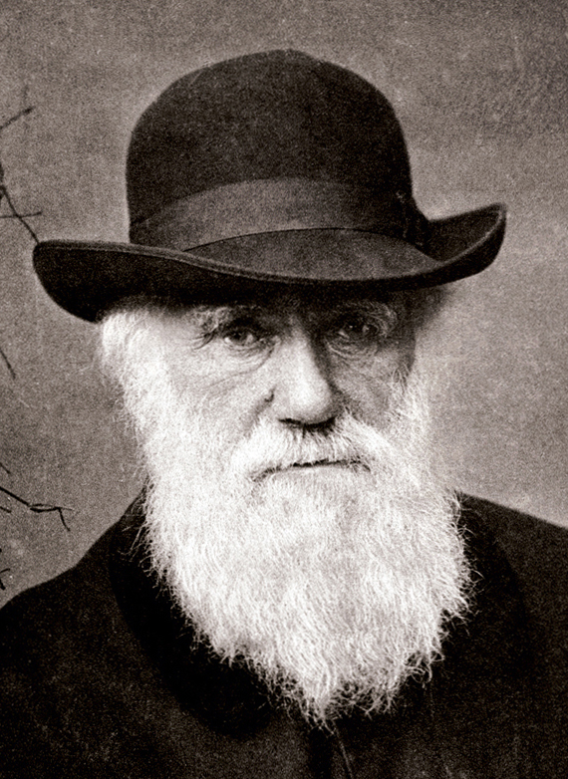
History and Approaches

Naturalist - research and writings on the origin of species had a direct influence on the early school of psychology known as functionalism

Stanley Milgram
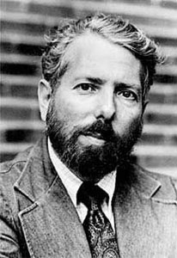
Social Psychology

Conducted controversial research on social obedience
*People follow orders from authority figures
*Used to explain Holocaust

B.F. Skinner
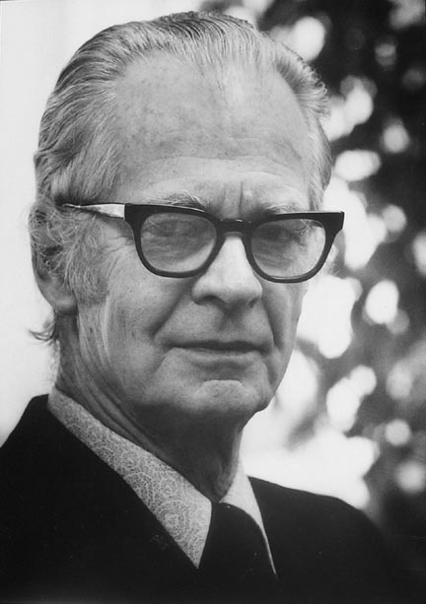
Learning/ Treatment

One of the most influential psychologists of the late 20th century advocated the idea that behavior is controlled by its consequences

*behaviorism
*schedule of reinforcement

Erik Erikson
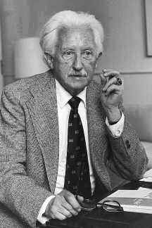
Developmental

Developed an eight-stage theory of psychosocial development beginning with trust versus mistrust.

Sigmund Freud
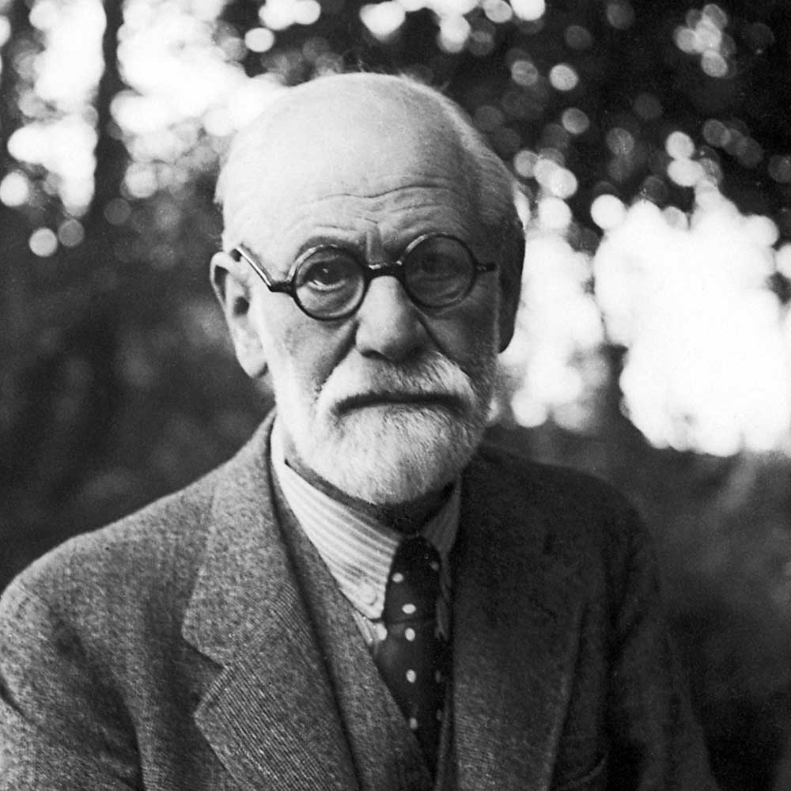
Personality/ Treatment/ Development

Founder of the psychoanalytic school of psychology through his development of the id, ego, and superego.

*unconscious

Roger Sperry
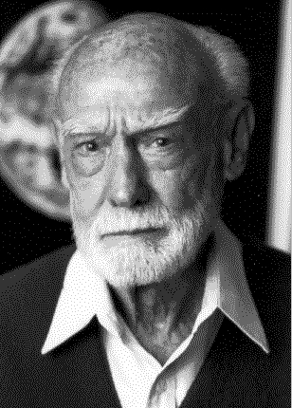
Biology

Nobel Prize for his research on split-brain patients who had their corpus callosum cut.

William James
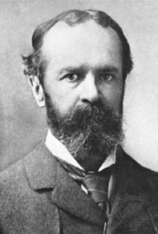
History and Approaches

The Principles of Psychology
Influence on the early development of psychology, along with his theory of emotions with Carl Lange.

Ivan Pavlov
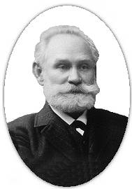
History and Approaches

Nobel Prize for work in the area of digestion, discovered that animals could learn to respond completely arbitrary stimuli.

Classical conditioning.

Alfred Adler
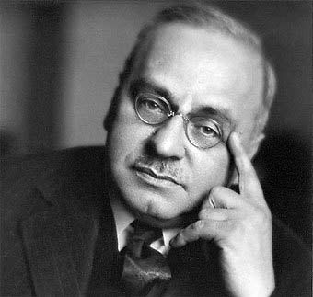
Personality

Psychodynamic

Founder of Individual Psychology who developed the idea of “striving for superiority” and the “inferiority complex”

Solomon Asch
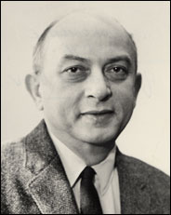
Social Psychology

Social psychologist who studied conformity and how group pressure affects distortion of judgement by asking subjects to compare the lengths of different lines.

Hans Eysenck
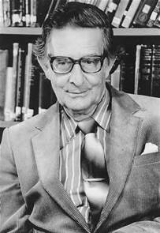
Personality

Proposed that personality was made up of two dimensions:

- introversion vs extroversion
- Emotionality (psychoficism) vs. stability (neuroticism)

Carl Jung
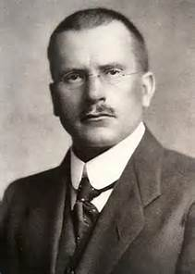

Personality

Developed the concept of the collective unconscious and archetypes

Founded The Analytical School of Psychology

Franz Mesmer
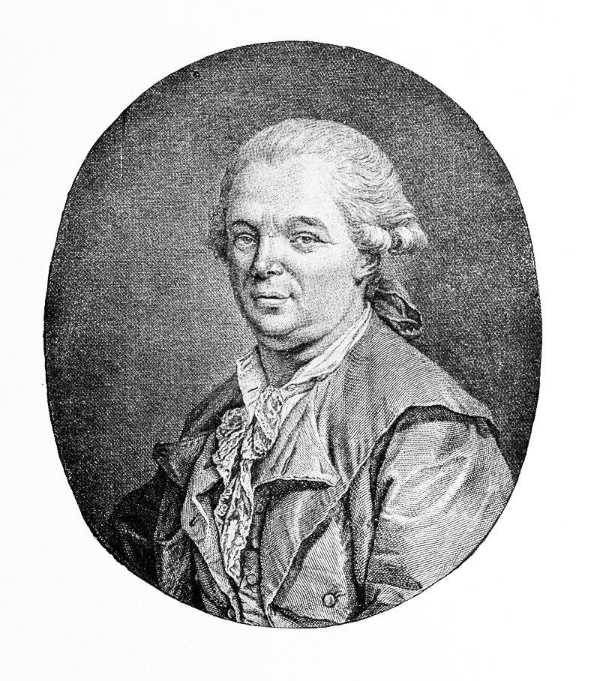
State of

Consciousness

One of the first to use hypnosis to help patients

He would “magnetize” his patients, harnessing their “animal magnetism” to cure their problems.

Noam Chomsky
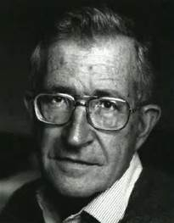
Cognition

Linguist who suggested humans have an inborn or “native” propensity to learn to talk

Universal Grammar

Paul Ekman
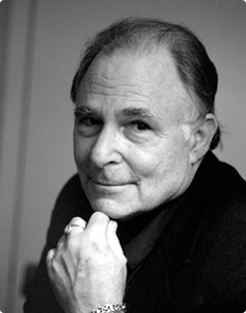

Emotion

Studied facial expressions and found cross- cultural agreement on the interpretation of facial expressions.

Micro-expressions (lying)

Facial Feedback Theory

Herman Rorschach
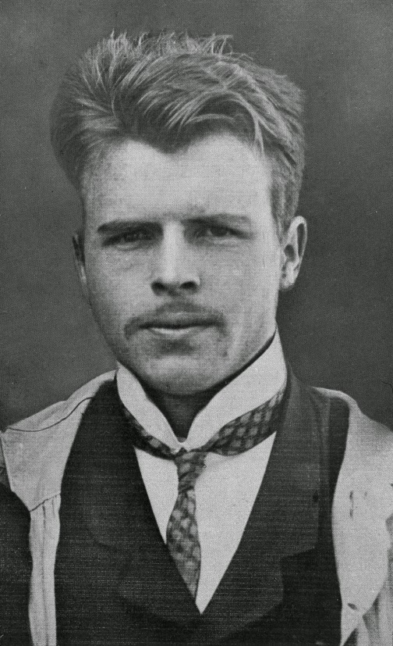
Personality

Swiss psychologist

Developed the inkblot test (projective test)

David Wechsler
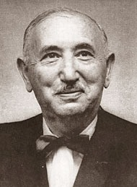
Testing/Individual Differences

Developed an intelligence scale (test) which stressed both verbal and nonverbal intelligence.

Carl Lange
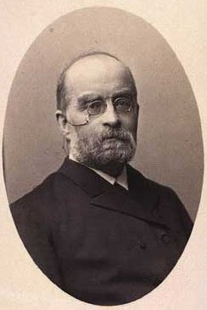

Emotion

With William James developed a theory of emotions whereby emotions are the result of bodily reactions

Lewis Terman
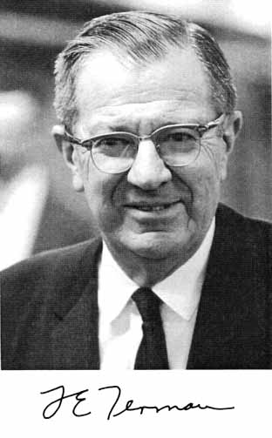

Testing/Individual Differences

American psychologist who made major revisions of Binet’s intelligence test to create The Stanford-Binet Intelligence Scale

Walter Cannon
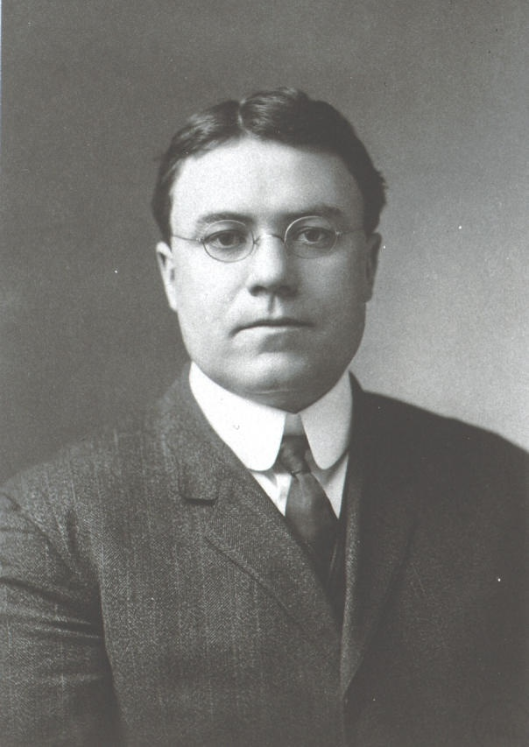
Emotion

Along with Bard, suggested emotional sensory information first reaches the thalamus, then simultaneously are felt and cause a bodily reaction

Robert Sternberg
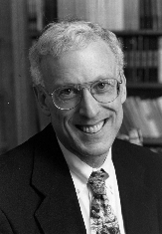
Testing/Individual Differences

Proposed a Triarchic theory of intelligence
-analytical
-creative
-practical

Triarchic theory of love

Karl Wernicke
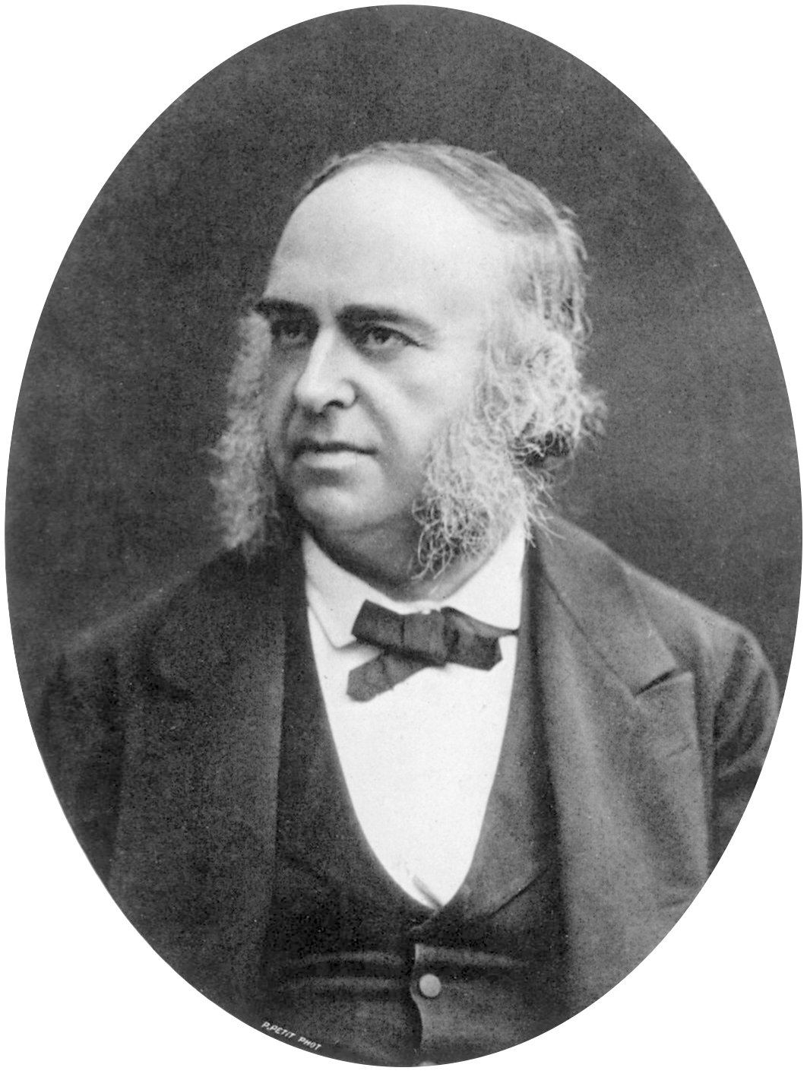
Biology

German neurologist who discovered the part of the brain responsible for the comprehension of speech

Howard Gardner
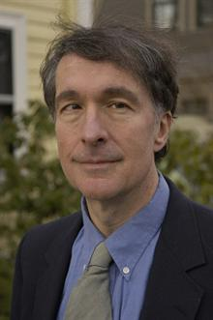
Testing/Individual Differences

Divided intelligence into 8 different types; logical- mathematical, linguistic, musical, spatial, bodily-kinesthetic, interpersonal, intrapersonal, and naturalist.

-Very controversial
-Used in education

Martin Seligman
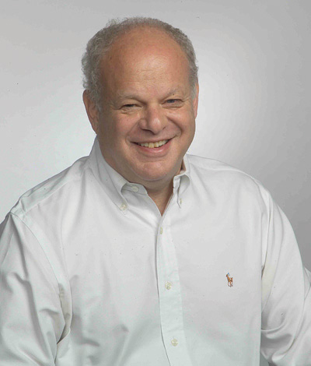
Learning

American psychologist, proposed learned helplessness can cause depression or other mental illnesses;

Current advocate of positive psychology

Wilhelm Wundt
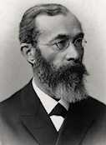

History and Approaches

In 1879, established the first psychology laboratory in Leipzig, Germany

John Locke
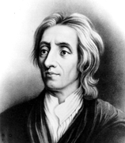

Personality

English philosopher argued every person begins life as “tabula rasa” (“blank slate”) and all knowledge is the result of experience, a view that became known as empiricism

Karen Horney
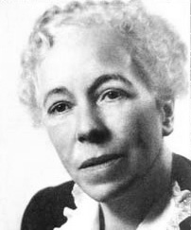

Personality

Charged that psychoanalytic theory as developed by Freud was male-biased and proposed a more social-cultural approach to balance the masculine view of psychology of the time

Hermann Ebbinghaus

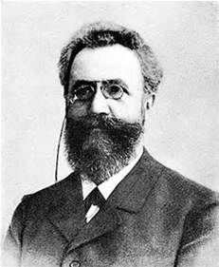
Cognition/Memory

Developed a rigorous empirical approach to the study of memory and the “forgetting curve”

Sir Francis Galton
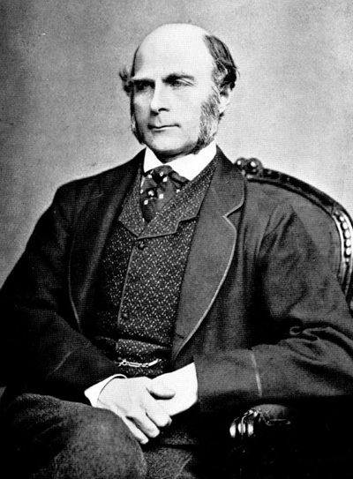
Biological

Cousin of Darwin

English scientist who coined the term “nature vs nurture” and a firm believer in the eugenic theory.

Harry Harlow
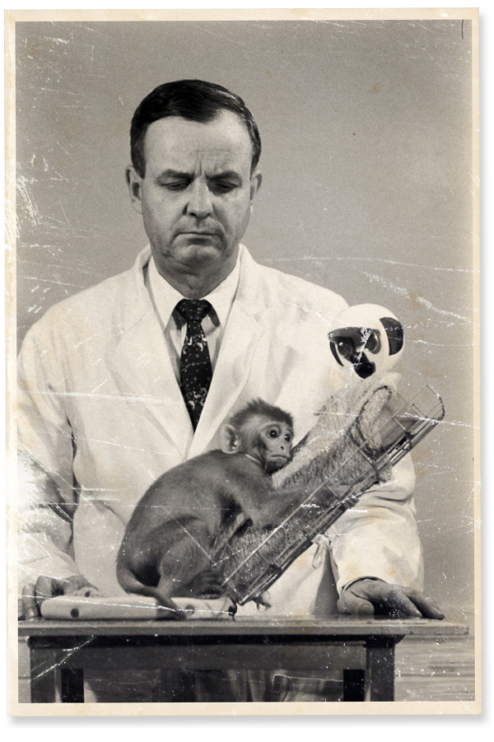
Developmental

American psychologist who studied attachment to caregivers in infant monkeys

Adelbert Ames
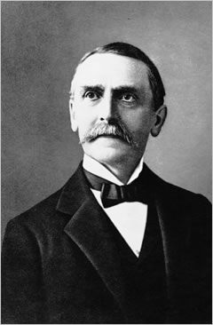

Sensation/Perception

Developed a distortion room that is named after him where people of similar sizes appear to be at different heights.

Carol Gilligan
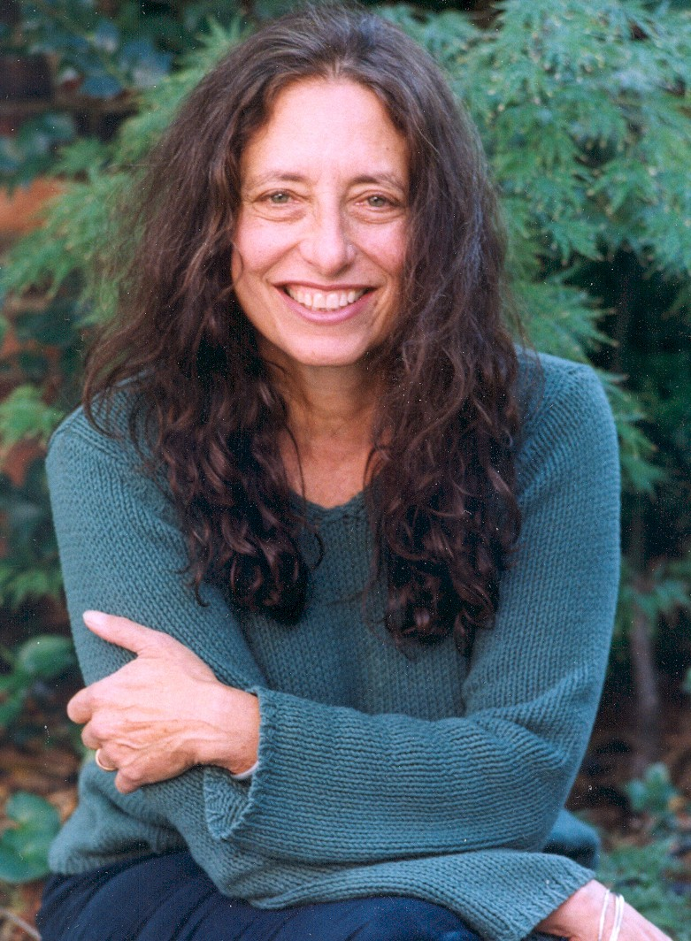
Developmental

American psychologist

Researched differences between males and females in moral development

Believed that females tend to lean more towards fulfilling human needs and are more relationship oriented than males. Men =Justice

Lev Vygotsky
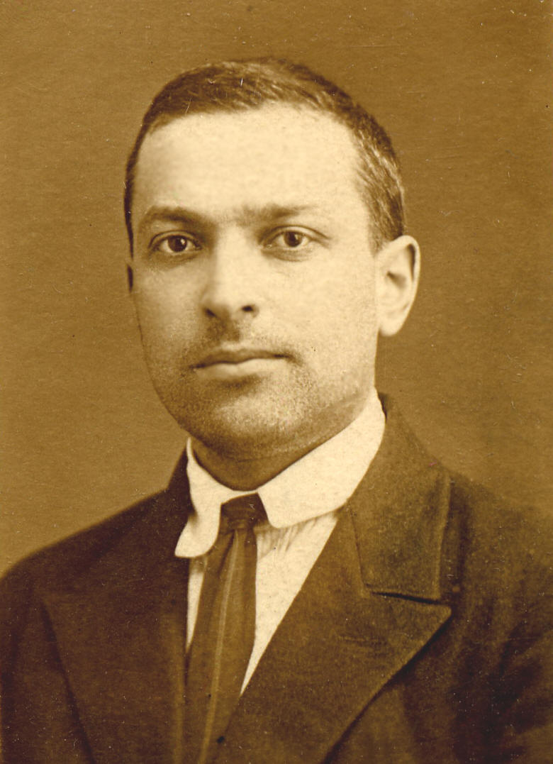
Developmental

Russian cognitive theorist
Emphasized the role of the environment, especially the social world of people, in intellectual development and the “zone of proximal (potential) development.”

Gordon Allport
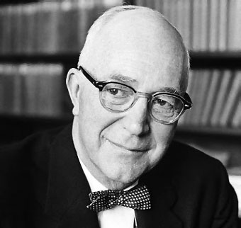
Personality

Founder of Trait Theory

Believed personality can be described in terms of fundamental traits that he divided into three kinds of traits: cardinal, central and secondary traits

Raymond Cattell
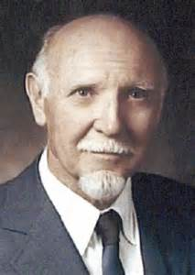
Personality

Trait theorist who divided personality into 16 factors

Suggested there were two types of intelligence- fluid and crystallized

G . Stanley Hall
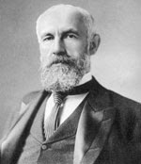
History and Approaches

Established the first American psychology research lab (Johns Hopkins, 1883) established the first professional journal in psychology (American Journal of Psychology,1887) and founded American Psychological Association (1892)

Dorthea Dix
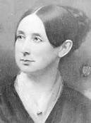

Abnormal

American activist on behalf of the insane who created the first generation of American mental asylums.

Michael Gazzaniga
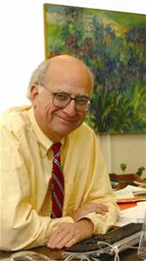
Biology

Led pioneering studies in learning and understanding split brained patients and how their brains work

Gustav Fechner
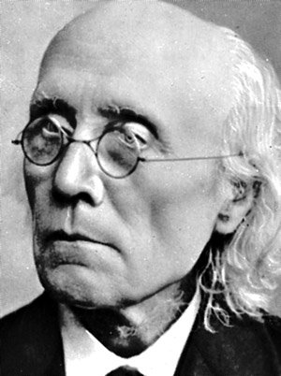
Experimental/
Sensation/Perception

Early German psychologist credited with founding psychophysics

Ernst Weber
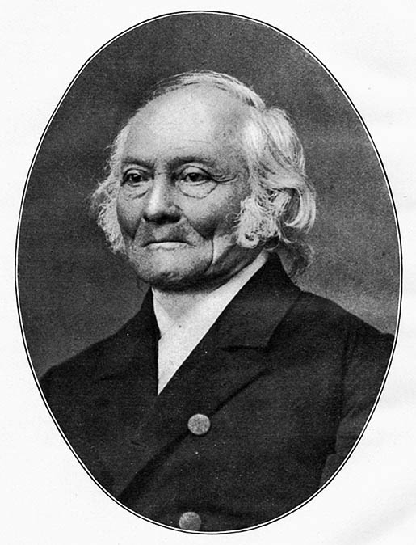

Experimental/
Sensation/Perception

Studied absolute threshold and JND (Just Noticeable Difference) between two stimuli

David Hubel
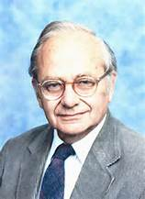

Sensation/Perception

Studied the structure and function of the visual cortex

Co-recipient with Torsten Wiesel of the Nobel Prize in Physiology for their discoveries concerning information processing in the visual system.

Feature Detectors

Torsten Weisel
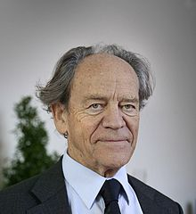
Sensation/Perception

Studied of the structure and function of the visual cortex

Co-recipient with Hubel of the Nobel Prize in Physiology for their discoveries concerning information processing in the visual system.

Feature Detectors

Ernest Hilgard
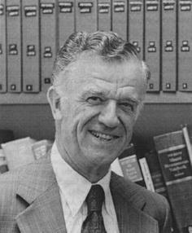
States of Consciousness

Research on hypnosis, especially with regard to pain control

John Garcia
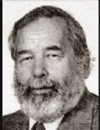

Learning

Conditioned taste aversion

Survival mechanism due to the fact that people/animals can decipher whether the food is poisonous or not; which essentially can avoid sickness or death

Ex. Poisoned Sheep and wolves

Robert Rescorla
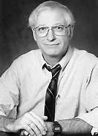
Learning

American psychologist who experimentally demonstrated the involvement of cognitive processes in classical conditioning

Edward Tolman
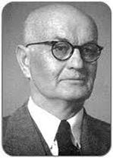

Learning

Behaviorist, demonstrated that rats that had incorrectly explored a maze that contained food while they were not hungry, were able to run it correctly on the first trial when they entered it having now been made hungry

Wolfgang Kohler
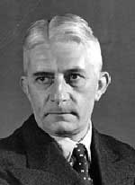
Sensation/Perception/Cognition

Cofounder of Gestalt Psychology

Studied insight learning which he tested on animals, particularly chimpanzees

Elizabeth Loftus
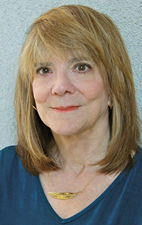
Cognition/Memory

Studied repressed memories and false memories

Showed how easily memories could be changed and falsely created by techniques such as leading questions and illustrating the inaccuracy in eyewitness testimony

George A. Miller
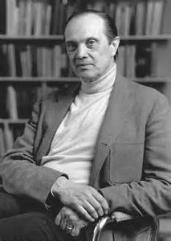

Cognition/Memory

Found that short term memory has the capacity of about 7 (plus or minus 2) items

Alfred Kinsey
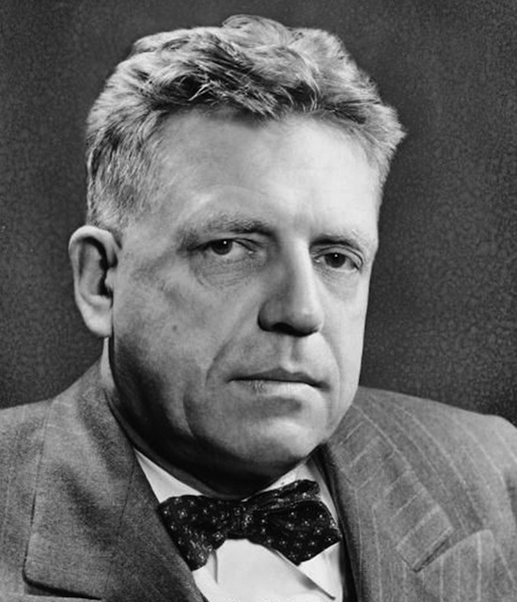

Motivation

His research described human sexual behavior (orientation) and was controversial (for its methodology & findings); Kinsey report, Kinsey scale

Stanley Schachter
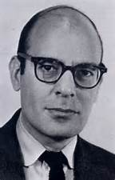

Emotion

Developed "Two-Factor" theory of emotion (with Singer); experiments on spillover effect

Mary Ainsworth
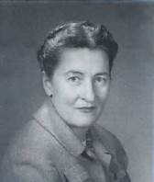
Developmental

Studied attachment in infants using the "strange situation" model. Label infants "secure", "insecure" (etc.) in attachment

Diana Baumrind
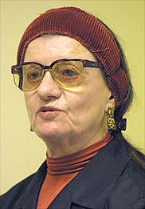

Developmental

Her theory of parenting styles had three main types (permissive, authoritative, & authoritarian)

Konrad Lorenz
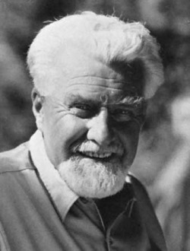

Developmental

Nobel Prize for research on imprinting

Charles Spearman
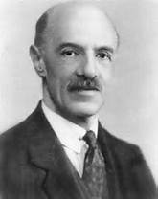
Testing/Individual Differences

Creator of "g-factor", or general intelligence, concept

Philip Zimbardo
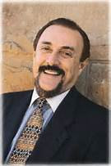

Social Psychology

Proved people’s behavior depends to a large extent on the roles they are asked to play

Stanford Prison Experiment

Leon Festinger
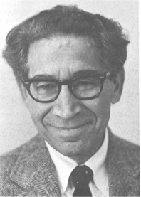
Social Psychology

Described concept of cognitive dissonance
Aaron Beck
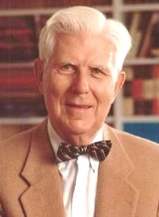
Treatment/ Therapy

Developed cognitive-behavior therapy

