DO YOU WANT TO BE AWSUM?!
If you are interested in being a member of AWSUM Club for the 2016-2017 school year, you will need to fill out the form below. Dues for this year will be $20 and will include a T-shirt. We will also use part of the dues this year as our donation to the Special Olympics so that you do not have to complete a fundraiser. To be a member of AWSUM Club, forms must be turned into Ms. Silver no later than NOON on September 23, 2016. Be sure to hand them to Ms. Silver so that your money is accounted for.
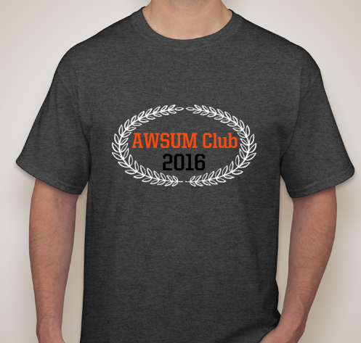

*We will have signatures of members on the back. Shirts will be gray with orange and black letters.
AWSUM is a community service club that also gets together for fun events. You will earn points for the events you volunteer at. We will take a day off school to help Special Olympics at the end of the year, and you will be chosen based on points. You will NOT be invited to Special Olympics if you do not participate in at least one event and attend at least three of the meetings.

Please fill out the following form and return with $20 in an envelope to Ms. Silver by September 23, 2016. You need to get these to her no later than noon on the day you turn them in. Checks must be made payable to NCHS and include a phone number.
Name (Please Print)______________________________________________
Adult T-Shirt Size (circle one) S M L XL XXL
2nd Period Teacher ______________________________________________
Email Address __________________________________________________
Do you want an officer to text reminders? If so text 81010 with the message @awsumclub

