A Day in the Life of an Elementary Remote Learning Student

Time | Activity
60 minutes | 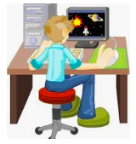 | Watch and Learn/Independent Practice Activities  (select from ELA, Math, Science, Social Studies, Encore, etc.)
15 minutes |  | Brain Break  (GoNoodle, color, grab a snack, call a friend, etc.)
20-25 minutes |  | Independent Reading & Reflection
20 minutes |  | i-Ready Math
20 minutes |  | Brain Break  (GoNoodle, color, grab a snack, call a friend, etc.)
15 minutes | 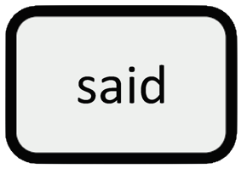 | VocabularySpellingCity.com
15 minutes | 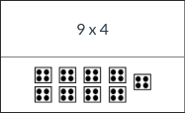 | Math Fraction Challenges: desmos.com  (follow link from math teacher)
20 minutes |  | i-Ready Reading
5-10 minutes |  | Share work and/or Check-In with Teacher

