AP United States History – Period 4 Syllabus
Kennedy, The American Pageant- Chapters 10-15
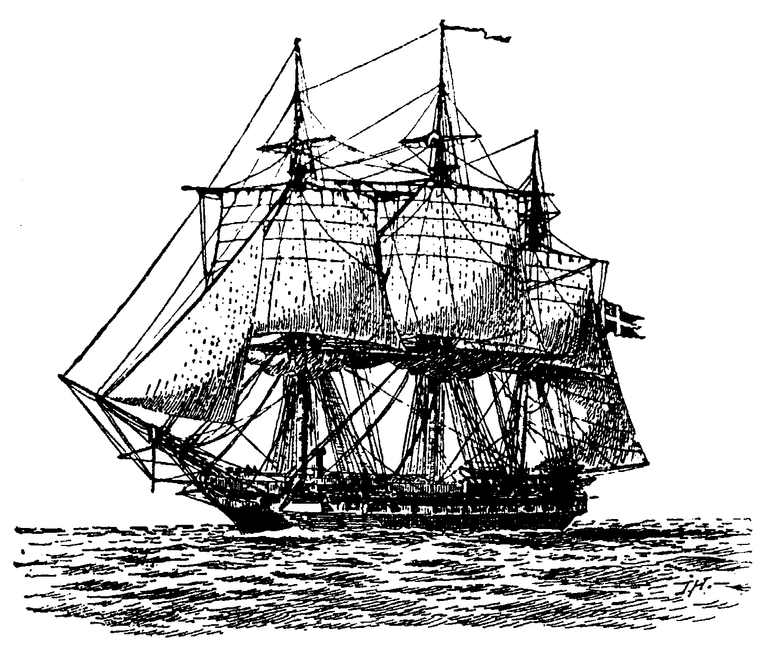

Major Themes: - Period 4 (1800-1848)
The promise of the new republic played out during a period of rapid economic, territorial, and population growth that tested the political institutions that held the nation together.

AP Objectives:
4.1: The United States began to develop a modern democracy and celebrated a new national culture, while Americans sought to define the nation’s democratic ideals and change their society and institutions to match them.
4.2: Innovations in technology, agriculture, and commerce powerfully accelerated the American economy, precipitated profound changes in U.S. society and to national and regional identities.
4.3: U.S. interest in increasing foreign trade and expanding its national borders shaped the nation’s foreign policy and spurred government and private initiatives.

Date | Topic | Reading
Monday 3/2 | Adams Live Lecture, Key Terms & People, Intro Project | Ch. 10, Begin Portfolio Items
Tuesday 3/3 | Teacher Workday
Wednesday 3/4 | Jeffersonian Democracy | Ch. 11 with Conflict Chart
Thursday 3/5 | War of 1812 | Ch. 12 with reading guide
Friday 3/6 | Nationalism: Marshall Cases Activity | Ch. 13- Pgs. 299-310
Monday 3/9 | Jacksonian Democracy | Ch. 14 with reading guide
Tuesday 3/10 | Sectionalism: The Market Revolution, Superheros Due! | Ch. 15 – Pgs.342 - 361
Wednesday 3/11 | Slavery and Reform, Scavenger Hunt | Study and complete Portfolio items
Thursday 3/12 | Period 4 Test, Portfolios Due

