Notebook #

Name _____________________________________________________ Class____________ Date ___________

Traits Activity

Direction: Examine your self for the following traits. Answer the questions as you examine each trait. Then fill out the survey on the last page, including your genotype for each trait. Survey family members so that we can develop a pedigree for different traits in your family.

- If you have the ability to roll your tongue into a tube-like shape, you are a "roller." Tongue rolling is determined by a dominant allele, R. If you cannot roll your tongue, you are homozygous recessive (rr).
What is your phenotype? __________________________ What is your genotype? _______________________

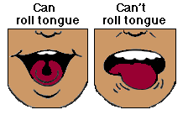

- Examine your hairline. If you have a pointed hairline forming a V, you carry a dominant allele for a widow's peak (W). If your hairline is straight, you are homozygous recessive for this trait (ww).
What is your phenotype? __________________________ What is your genotype? _______________________

- Examine your ear lobes. If your ear lobes are detached, even partially, from the side of your face, you possess the dominant trait "detached ear lobes" (E). If your ear lobes are attached to the side of your face, you are homozygous recessive (ee).
What is your phenotype? __________________________ What is your genotype? _______________________

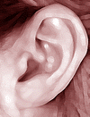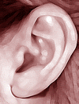

- Hold out one hand with the fingers together. If the end joint of your little finger bends inward, you have the dominant allele for the trait (F). If your little finger is straight, you are homozygous recessive (ff).
What is your phenotype? __________________________ What is your genotype? _______________________

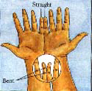

- Hold your hand out and make a first with your thumb extended. If the end segment of your thumb extends at an angle of less than 90 degrees from the thumb, then you are homozygous recessive for hitchhiker's thumb (hh). If the end segment extends at an angle of at least 90 degrees out from the rest of your thumb, then you have the dominant allele for the trait (H).
What is your phenotype? __________________________ What is your genotype? _______________________

- Each of your fingers is composed of three segments. If any hair grows on the middle segment, you have the dominant allele for mid-digital hair (D). If you don't have any hair on any of the middle segments of your fingers, you are homozygous recessive for this trait (dd).
What is your phenotype? __________________________ What is your genotype? _______________________

- If you have blue eyes, you lack pigment on the outer layer of your iris and are homozygous for this trait (ii). If there is any color other than blue in your iris, you have a dominant allele for eye pigment (I). The exact eye color of a non-blue-eyed individual is controlled by other genes, which code for eye pigments of various colors of brown, green, hazel, or a combination of colors.
What is your phenotype? __________________________ What is your genotype? _______________________

- A dimpled chin is caused by a dominant allele, M. If you have this feature, you are either homozygous dominant or heterozygous dominant for this trait. If you lack a dimple, you are homozygous recessive (mm).
What is your phenotype? __________________________ What is your genotype? _______________________
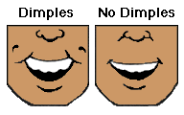

Color Blind Tests
The following list includes Internet sites where tests for color blindness may be performed:
http://www.toledo-bend.com/colorblind/Ishihara.html
http://www.colorblindtest.com/index.htm -
http://www.geocities.com/Heartland/8833/coloreye.html -
- The allele for this trait is located on the X chromosome and is thus said to be sex-linked. If you see colors normally, you carry the dominant allele for this trait (either X^{B}X^{B} or X^{B}X^{b} for females and X^{B}Y for males). If, on the other hand, you are red-green colorblind, you carry the recessive allele. Colorblind males are X^{b}Y, and colorblind females are X^{b}X^{b}.
What is your phenotype? __________________________ What is your genotype? _______________________

- Hallux Length Some individuals have a hallux (big toe) that is shorter than their second toe. If necessary, take one shoe off and feel through your sock. The dominant phenotype is long second toe. The genotype is BB or Bb. The recessive phenotype is a long big toe or equal to second toe. The genotype is bb.
What is your phenotype? __________________________ What is your genotype? _______________________

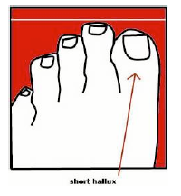
- Can you make a Vulcan hand sign? Star Trek’s Mr. Spock greets people with a “v” hand sign. Try to spread your fingers into a “v.” The Vulcan is the dominant phenotype, genotype VV or Vv. The earthling sign is the recessive, genotype vv.
What is your phenotype? __________________________ What is your genotype? _______________________

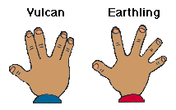

- Interlocking Fingers: Fold your hands together by interlocking your fingers. Which thumb is on top? If the left thumb is on top, you are dominant (T-). If the right thumb is on top, you are recessive (tt)
What is your phenotype? __________________________ What is your genotype? _______________________

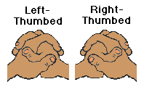

- Index Finger Length Relax your right hand on this sheet of paper so your middle finger lies on top of line x (below) and the end of your fourth finger (ring finger) is in line with line y. If your second finger (index finger) does not reach to the top of line y or beyond, you have a short second finger. Short index finger is dominant (I). A long index finger is recessive (ii).
What is your phenotype? __________________________ What is your genotype? _______________________

- Freckles: If you have freckles then you have a dominant gene (F-). If you don't have freckles then you are recessive (ff).
What is your phenotype? __________________________ What is your genotype? _______________________
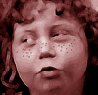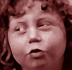
Direction: Fill in this table with your results. Look under description of each trait for your GENOTYPE. NOTE- You will be answering if you have the DOMINANT Trait

 | TRAIT | YES | NO | GENOTYPE
1 | Tongue Roll
2 | Widows Peak
3 | Detached ear Lobe
4 | Bent Little Finger
5 | Hitchhikers Thumb
6 | Mid-digital Hair
7 | Other than Blue Eyes
8 | Dimpled Chin
9 | Normal Color Vision
10 | Long Second Toe
11 | Vulcan Sign
12 | Left Thumb Interlock
13 | Short Index Finger length
14 | Freckles Present

Direction: Survey as many family members as you can and record.

 |  | MOM |  | DAD |  | Sis/Bro  (circle) |  | Sis/Bro  (circle) |  | Who? |  | Who?
 | TRAIT | YES | NO | YES | NO | YES | YES | NO | NO | YES | NO | YES | NO
1 | Tongue Roll
2 | Widows Peak
3 | Detached ear Lobe
4 | Bent Little Finger
5 | Hitchhikers Thumb
6 | Mid-digital Hair
7 | Other than Blue Eyes
8 | Dimpled Chin
9 | Normal Color Vision
10 | Long Second Toe
11 | Vulcan Sign
12 | Left Thumb Interlock
13 | Index Finger length
14 | Freckles Present

