ES Living Environment

20012-2013 Living Environment ES Course Outline

Teacher: Mr. Bonadonna
michael_bonadonna@bcsd.org
phone: (585)242-5050
Classroom : 372 Office: 372/374

Living Environment (formerly “Regents Biology”) is a lab-based science course that includes lectures, labs, class discussions, student presentations, hands-on activities, and field trips. The environment is student-centered and discovery based. You will be encouraged to participate actively in class and lab. Many of our activities are designed around current events in order to promote critical thinking skills and emphasize connections between our science classroom and the real world.

Course Schedule

Topics Field Trips/Features
Introduction Scientific Method
What is Life?

Ecology Ecosystems
How Ecosystems Change Brighton Town Park Trip
Environmental Problems
Classification and Taxonomy

Biochemistry Chemistry of Biology

Cells Bacterial, Plant, & Animal Cells

Energy Photosynthesis and Respiration

Winter Break 12/22-1/2
Mitosis & Meiosis

Midterms 1/22-1/25
Genetics Genetics and Inheritance
DNA and RNA – Molecular Genetics

February Break 2/18-2/22
Genetics (cont’d) Biotechnology

Evolution Evolution and Extinction

Human Systems Digestion, Gas Exchange, and Excretion
Circulation and Blood

April Break 4/1-4/5
H. Systems (cont’d) Immune System Whale Watch Trip (5/3-5/6)
Nervous System Fetal Pig Dissection
Hormones
Reproduction & Development

Final Exams 5/7-5/21

CODE OF CONDUCT AND GRADING POLICY
Mr. Bonadonna-Living Environment ES

Philosophy:
We learn best when we are actively engaged in what happens in the classroom. To create the environment for learning, everyone’s help is needed.

Attendance:
It is very important to attend class on a regular basis. Students who have been absent must complete the work they have missed. It is the responsibility of each student to request make-up work. Upon returning to school after an excused absence, students are permitted three days to complete the work. If an absence is unexcused, the student may not receive credit for the make-up work.

Lateness:
Students are expected to be in their seats when the bell rings. Three tardies will result in a detention.

Language:
Everyone should always use complete sentences. No profanity or offensive language is allowed.

Mutual Respect:
The classroom environment must foster the climate of discussion. The rules of common courtesy should be observed at all times. In class, everyone has a voice and knowledge to share. We must also respect the classroom. Remember, we are sharing this room with seven other classes.

-While others have the floor, respect their rights to talk uninterrupted.
-Keep your hands to yourself (If it’s not yours, don’t touch it; this includes other people)
-Straighten your desk and chair before you leave the classroom.
-Pick-up and discard any trash when you leave.

Due Dates for Assignments:
All assignments are due at the beginning of each class on the assigned date. If you forget it in your locker, you may ask to get it before the bell rings. Once class has begun, if it was left at home, etc., it is late. A late assignment may be turned in with a 20% deduction per day.

Grading:
Grades will be divided into one of three categories each weighted differently. Grades are kept numerically and are converted into letter grades at the end of the marking period. Below is a list of how each of these categories will be weighted:

Grades: Homework 15%
Labs 25%
Tests/quizzes 60%

There are opportunities to improve grades. For example, if you bring in an abstract, from a scientific journal, you will receive bonus points on your homework grades. There will be a maximum of 0.5% towards your overall average for abstracts and extra credit. On many occasions, if you correct your tests and quizzes in complete sentences with an explanation for the correct answer, you will receive half of the points which were taken away. There will be a maximum grade of a “C” rewarded for these corrections. If on any unit test you score less than an 80%, you may retake that exam. Test corrections are required before you are eligible for a retake. Extra credit will only be accepted after all regularly scheduled assignments are satisfactorily completed.

Discipline Policy:
As you are aware Brighton High School has several disciplinary levels. These levels and guideline will be followed in this class. The action taken for the first level one offense will be a verbal warning. I believe everyone should get a second chance throughout the year (these offenses are cumulative). The second offense will warrant a call home. The third offense will be a detention. The fourth offense is a referral to the assistant principal. Any single action may warrant a more serious response as described in the student handbooks.

Lab

* Labs must be one in duplicate, my suggestion is to take notes in a composition notebook and write them on the computer.
* Completion of labs is a State requirement before taking the regents at the end of the year. Your printed labs will be kept in a lab folder in the classroom.
* Points are deducted for lateness, incomplete or messy work, and grammatical errors. You do not receive credit for lab hours of failing work.
* Labs are double periods.
* You must keep your own notes during labs and write your lab reports based on your own work. Copying work you did not do, assist with, or record is a violation of the “ Academic Honesty” requirements. Collaboration and teamwork are required, but copying or allowing someone else to copy your work is considered cheating.

Research Project

You will be required to complete a research project before the completion of this course. We will begin to develop ideas for this project within the first five weeks of school. The completed project will include: a proposal with background information, original research, power point and poster presentations, and a group formal research report. Science Congress is a Regional, and State research competition for students. Science Congress Club will be held after school for those students who would like to participate. The guidelines for Science Congress will be followed for all projects. More information on Science Congress will follow.

Food
No food or beverages allowed in the classroom or lab. This is a health and safety issue. The desktops may be contaminated with chemicals or bacteria. You will find this policy is followed in all laboratories in the world.

HELP!

If you have a question, ask. Most people need help at one time or another. I am available for help at various times. My schedule and office hours are posted outside my office door. If you have questions or problems, or need to schedule a time to see me, please ask.

Miscellaneous Information
* Notes will typically be given in outline form. Try and take good notes.
* Read the text, even though it won’t be assigned (It’s got great pictures).
* Make flash cards, vocab is huge!
* Number your handouts and notes consecutively. Keep track of them in a table of contents.
* Date your notes and handouts
* If you miss or do not understand something, ask to have it repeated.
* Take notes on only one side of the page. It will be easier to read them later.
* Keep up with your work. Catching up is one of the hardest things to do.

If you have any questions please contact Mr. Bonadonna in room 372/373, phone at 242-5050, or e-mail at michael_bonadonna@bcsd.org .

Abstract Guidelines

How to write an abstract

What is it?
An abstract is a simply a descriptive and evaluative summary of work. The source of work may include books, journal articles, newspaper articles, magazine articles, Internet articles, websites, or your own work.

How do you set it up?
Each item included in the abstract will have two parts to its entry: a complete bibliographic citation and the abstract itself. Check with the Brighton English Department Handbook for proper citation of articles.

How do you write an abstract?
An abstract contains four sequential elements, each of which should be covered by two to three sentences at most:

- Purpose, Scope and Background.
What’s the subject of the article? Are there limitations imposed on its scope? Is there other research which supports the hypothesis? Try to identify why the author wrote the article. Is the intended audience a group of specialists, or does the article try to educate the lay person?

- Method.
Is the article a review of current literature, a description of an event or program, a reflective essay? If it reports an experiment, describe how it was conducted.

- Results and Conclusions.
If the article reports an experiment or describes a program, what was the outcome? Does the author make any recommendations for further action or draw any conclusions?

- Evaluation.
Was the argument convincing? Did the article explore new territory? Did it contradict other material you have read? Be critical, but if you are hard on a particular item be prepared to defend its presence in your bibliography. After all, if it is a piece of garbage, why did you include it?

A FEW WORDS ON STYLE:
- Be concise. You are trying to convey only the essence of a book or article, don’t waste words.
- Use complete sentences if at all possible and don’t abbreviate words.
- AVOID starting annotations with phrases like “THIS ARTICLE is about…” or “THIS INTERNET SITE is about…” Your reader already knows which article you are talking about.
- After you have written the annotation, reread it. It is hard to write clearly and concisely, don’t expect perfection from your first draft.

The complete BHS Handbook for Writing and Research can be found at:
http://bcsd.org/files/filesystem/WritingResearchHandbook.pdf

Sample Abstract:

Evans, Evelyn P., Stallions, Maria E., Damianos, Fred. “Charter Schools: Educational Evolution or Revolution?” The Educational Forum. Fall 1999, 20-24.

Associate Professor of Undergraduate Education at Barry University of Miami, Evelyn Evans, states that charter schools may revitalize public education, give parents a choice, and increase student achievement. Evans discusses the inception of the Miami Shores/Barry University Charter School, the successes that have become a part of the school, various teacher strategies, the type of assessments used, and development of a governing body to oversee school activities. It is concluded that charter schools have become a catalyst for policy change in funding, equity, accountability, and school choice. A very informative and thought provoking article for those wanting to know more about charter schools.

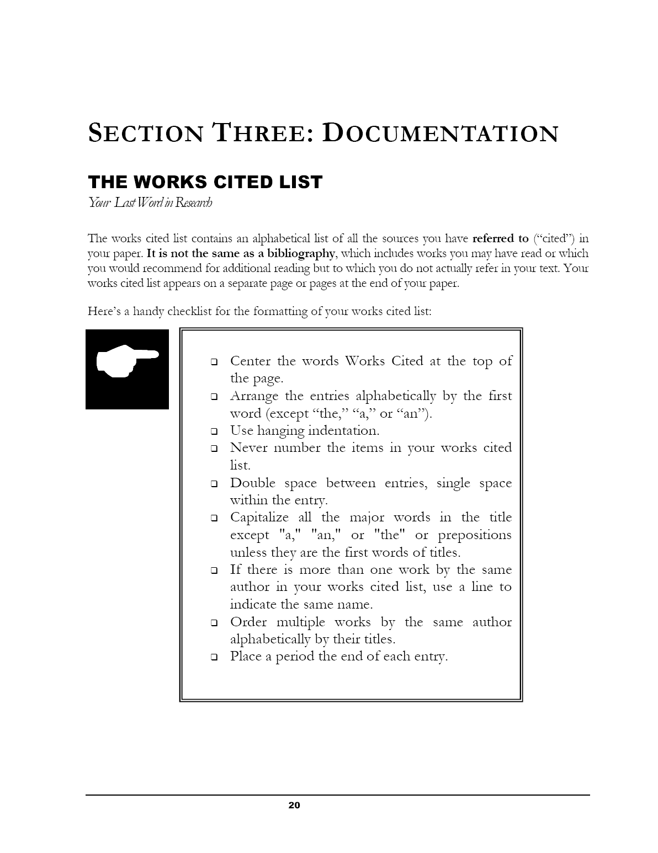

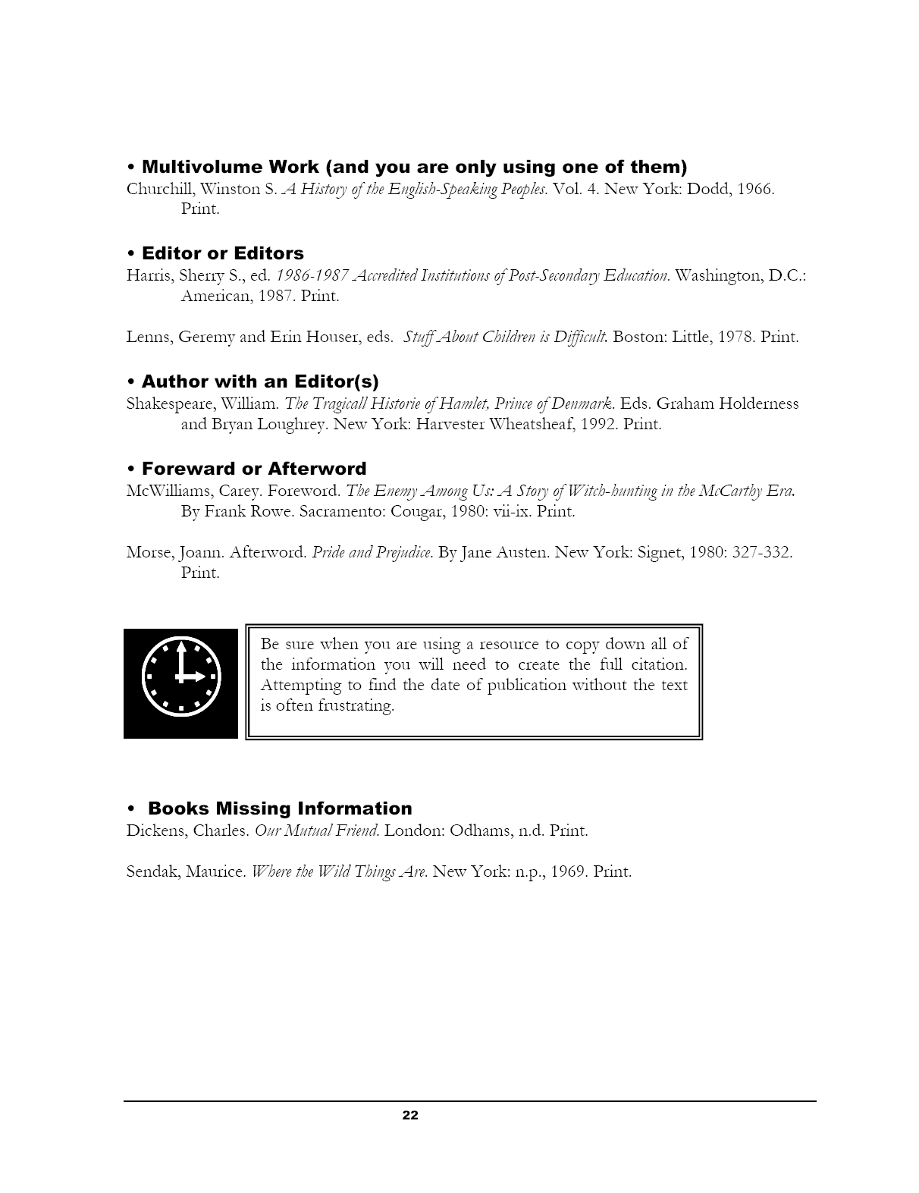

Name _____________________________ Section_____________________ Date___________#_____

It’s Alive, ALIVE, aaha, ha, ha, ha, ha!?!?!?!!?!

Station | Item | Living | Non-Living | Biotic | Abiotic | Organic | In-organic
1
2
3
4
5
6
7
8
9
10
11
12



What is life? ________________________________________________________________________

___________________________________________________________________________________

What is death?_______________________________________________________________________

Properties of Life

*

*

*

*

*

*

*

Name _____________________________ Section _________________ Date_________

Living Environment
Brighton High School
Mr. Bonadonna

Just the Facts

In the TV show Dragnet they say “Just the facts, ma’am.” French Scientist Jules Henri Poincare once said, “ Science is built up with fact, as a house is with stones. But a collection of facts is no more science than a heap of stones is a house.”

Compose a statement about the importance of facts in biology-and what it takes to make those facts science.

Name_____________________________ Section _____________________ Date_____________ #____

Are viruses alive?

Viruses cannot reproduce unless they invade a living cell. A virus consists of a protein coat surrounding a core of reproductive material, usually the hereditary chemical DNA. The virus injects its DNA into the living cell. The viral DNA then directs the cell to make material for the virus’s covering. The viral DNA also directs the cell to make more viral DNA. These components are then assembled inside the living cell, forming many new viruses. Eventually the cell bursts open, and the viruses are released. Then the viruses disperse. They remain unchanged until they come in contact with other cells, where the reproductive process begins anew. Viruses do not make or consume food in any way.


Virus
Virus attaches
to cell
Virus injects
DNA
Cell makes virus
Coat and DNA
New virus released

- One requirement of all living things is that they reproduce. Do viruses meet this requirement? Explain
_________________________________________________________________________________

_________________________________________________________________________________

- Do viruses have metabolism? _________________________________________________________

_________________________________________________________________________________

- Are viruses made of cells?____________________________________________________________

_________________________________________________________________________________

- Does heredity occur in viruses? _______________________________________________________

_________________________________________________________________________________

- Does homeostasis occur in viruses? ____________________________________________________

_________________________________________________________________________________

- Are viruses living things? ____________________________________________________________

Six Kingdom System of Classification

- Archaebacteria
  - Definition / Cell Structure (prokaryote or eukaryote) / Nutrition (autotroph or heterotroph) / & Other Characteristics

  - Examples
1.

2.

3.

II. Eubacteria
- Definition/Cell Structure/Nutrition/Characteristics

- Examples
1.

2.

3.

4.

- Protista
  - Definition/Cell Structure/Nutrition/Characteristics

  - Examples

- Fungi
  - Definition/Cell Structure/Nutrition/Characteristics

  - Examples

- Plantae
  - Definition/Cell Structure/Nutrition/Characteristics

  - Examples

- Animalia
  - Definition/Cell Structure/Nutrition/Characteristics

  - Examples

Classifying Living Things

Why Bother?

Origins of Classification – Aristotle

Linnaean system

Rules

King Phillip Crossed Over Foamy Green Seas

Classification and evolution

Convergent evolution

Coevoulution

Homologous characteristics

Analogous characteristics

What is a species

The 5 (or six?) kingdom system

**What defines the following Phyla and give examples: Cnidarians, Crustaceans, Mullusca, Annelids, Echinoderms, Chordates

***List the complete scientific name of modern humans

