Extra practice: Unit 5 Lesson 1: Polynomial

1.
f(x) = x² – 3x + 8
g(x) = x – 5

a. Find f(x) + g(x). State the degree for the result.

b. Find f(x) – g(x). State the degree for the result.

c. Find f(x)g(x). State the degree for the result.

2. For each graph, write an equation in factored and standard form. Then write the domain and range.
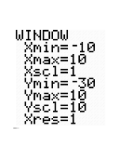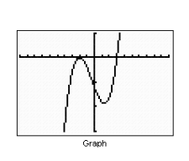

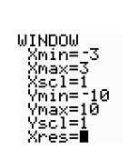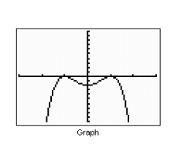

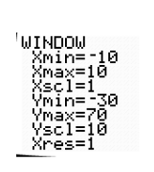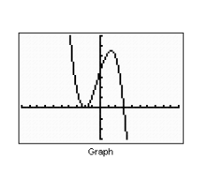

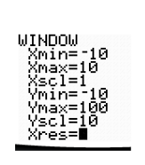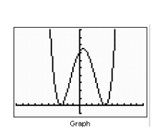

3. For each of the following sketch a graph.

a. f(x) = -x(x-2)(x+3)² b. g(x) = (x + 2)²(x-4)²

c. h(x) = (x+2)(x-1)(x+5) d. j(x) = x(x-4)(x-2)

Answers:

1a. x² – 2x +3

b. x² – 4x + 13

c. x³ – 8x² +23x - 40

2a. f(x) = (x – 3)(x + 2)²

b. f(x) = -2(x – 1)²(x+1)

c. f(x) = -3(x – 3)(x + 2)²

d. f(x) = 0.5(x + 3)²(x – 4)²

3a-d. Verify your sketches with your calculator.

