Ecology Project

Ecology is the study of the environment. We have learned about many different aspect of the biotic and abiotic environment including succession, interactions between organisms, and classification of these organisms. This project is designed to tie together all of these concepts of Ecology.

You are going to be in the position of an environmental engineer who has been hired by the Town of Brighton. As you know, Brighton has built a new park on Westfall Road. Before any construction began, an environmental survey had to be completed to ensure that the ecosystem where the new park and buildings are planned will not be disturbed. In the event that the town decides to expand the park to the east, a second survey must now be completed. That is where you come in. Now that you are an environmental expert, you need to show the Town of Brighton Planning Board the impacts of the new park.

You must present the Brighton Town Board with the following material:

- a list of 10 organisms with their common names and their Genus species names (they must be indigenous to New York State).
- cite the reference used to determine the Genus species and build a dichotomous key for all of the organisms (remember calling something a plant is not a description).
- pictures of the organisms or specimens (they must be indigenous to New York State).
- a food web showing the interactions and energy flow of these 10 organisms.
- an essay describing the effects on the ecosystem if natural setting is changed. Randomly, pick one of your organisms which will be eliminated from the food web and discuss the possible ramifications to the ecosystem and the species. You must then make your recommendation as to whether the project should be continued to benefit the public, or cancelled to benefit the environment.

Remember, you will be submitting your results to the Brighton Town Board. Your future as an Environmental Biologist relies on your accuracy and professionalism. All work must be submitted in a portfolio, on time, typed, and include a table of contents.

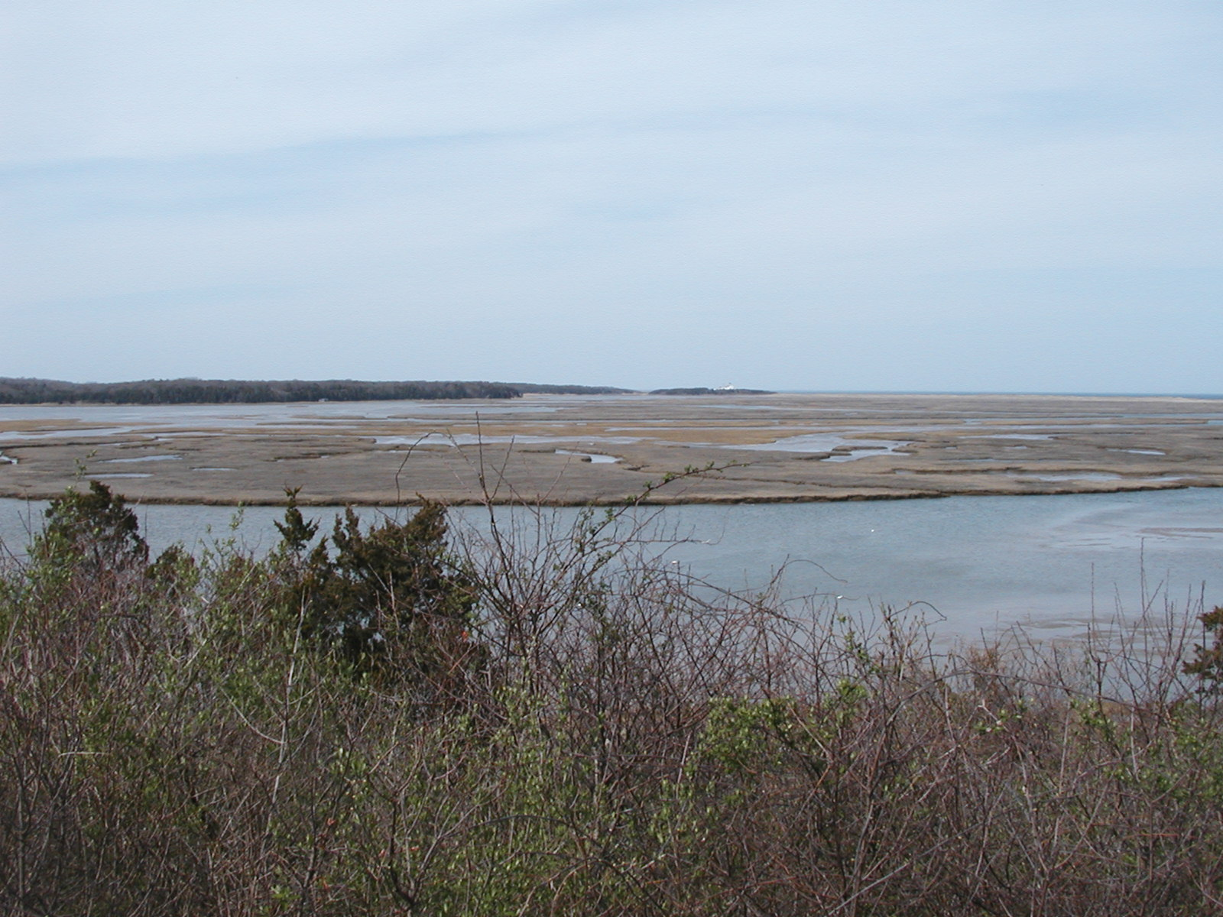
Ecology Project Rubric

 | 4 | 3 | 2 | 1
10 Organisms | All ten organisms live in the same ecosystem in NYS and are listed with both the common and scientific names. | One part for one organism is missing or inaccurate. | Missing two parts for one organism. | Missing one organism. Additional omissions adjusted accordingly.
Specimens | Specimens are photographed by you or preserved (only for invertebrates). Each organism is labeled with the common and scientific names. | One organism missing or incorrect. Or, all present but photos are taken from another properly cited source. | Two organisms missing or incorrect. Additional adjustments made accordingly. | Three organisms missing or incorrect. Additional adjustments made accordingly.
Food Web | All 10 organisms are shown with common names and show all possible energy flow relationships. | Energy flow incorrect or missing, or improper labeling for one organism. | Energy flow incorrect or missing, or improper labeling for two organisms. | Energy flow incorrect or missing, or improper labeling for three organisms.
Dichotomous Key | Does the key include all 10 organisms, use specific yes/no questions which clearly separate organisms using observable traits unique to all in each species, include Genus species name for all 10 organisms. | One organism is missing or a question does not clearly separate organisms. | Two organisms are missing or several questions do not clearly separate organisms. Additional adjustments made accordingly. | More than two organisms are missing or several questions do not clearly separate organisms. Additional adjustments made accordingly.
Mechanics | Correct grammar and spelling. | Occasional spelling or grammar errors. | Several grammar and spelling errors. | So many errors it distracts the reader.
Essay (x2) | An organisms role in the ecosystem is described. Effects of the removal of this organism is discussed in a non-biased manor substantiated with accurate facts. Recommendation is made and supported with details. | The role of the organism is described. The effects are stated and the recommendation is made but one of these are not supported well. | The role of the organism is described. The effects are stated and the recommendation is made but they are not supported well. | The role of the organism is not discussed in detail and the effects and recommendation are not supported well. Additional adjustments made accordingly.
Portfolio | Professional quality presentation with headings; TOC; clear pictures, diagrams, and specimens; digitally produced in a neat package. | Evidence of effort present. Untidy presentation with tape or glue showing. | Evidence of effort noticeable. Untidy presentation with tape or glue showing. Lettering done by hand | Little evidence of preparation.
Total out of 32

** Taxonomic identification not properly cited is minus two letter grades.

