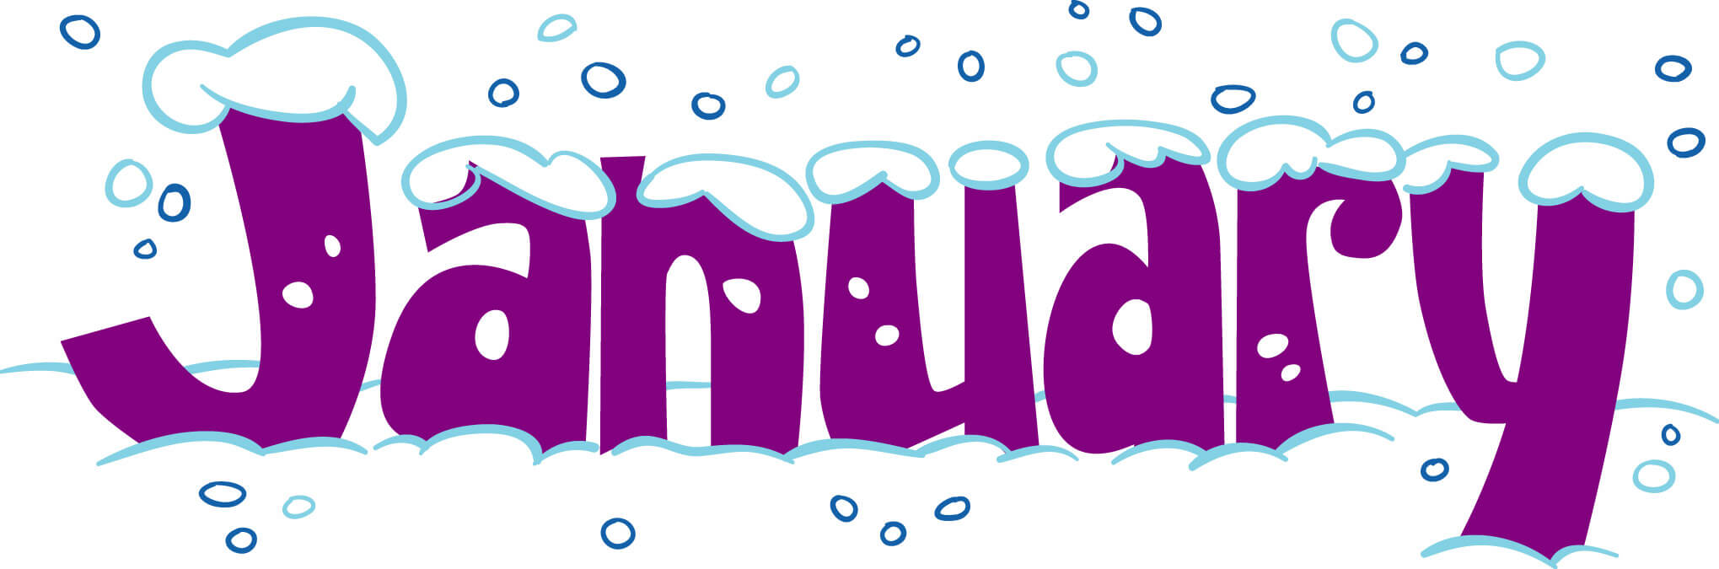2024
Breakfast Menu
Sunday | Monday | Tuesday | Wednesday | Thursday | Friday | Saturday
 | 1  NO SCHOOL CHRISTMAS BREAK | 2  NO SCHOOL CHRISTMAS BREAK | 3  Biscuits / Gravy  Cereal  Juice  Milk | 4  Breakfast Bars  Cereal  Juice  Milk | 5  DISTANCE  LEARNING - NO SCHOOL | 6
7 | 8  Oatmeal / Toast  Cereal  Juice  Milk | 9  Crispito  Cereal  Juice  Milk | 10  Sausage Biscuit  Cereal  Juice  Milk | 11  Breakfast Riser  Cereal  Juice  Milk | 12  DISTANCE  LEARNING - NO SCHOOL | 13
14 | 15  Breakfast Bars  Cereal  Juice  Milk | 16  Eggs / Hash Brown  Cereal  Juice  Milk | 17  Crispito  Cereal  Juice  Milk | 18  Breakfast Pizza  Cereal  Juice  Milk | 19  DISTANCE  LEARNING - NO SCHOOL | 20
21 | 22  Donuts  Cereal  Juice  Milk | 23  Sausage Biscuit  Cereal  Juice  Milk | 24  Egg & Cheese  Omelet  Cereal  Juice / Milk | 25  Rice  Toast  Cereal  Juice / Milk | 26  DISTANCE  LEARNING - NO SCHOOL | 27
28 | 29  Breakfast Bars  Cereal  Juice  Milk | 30  Biscuits / Gravy  Cereal  Juice  Milk | 31  Cinnamon Rolls  Cereal  Juice  Milk

Menu subject to change.
This institution is an equal opportunity provider.
2024
Lunch Menu
Sunday | Monday | Tuesday | Wednesday | Thursday | Friday | Saturday
 | 1  NO SCHOOL CHRISTMAS BREAK | 2  NO SCHOOL CHRISTMAS BREAK | 3  Stew  Cornbread  Cheese Stick  Fruit  Milk | 4  Salisbury Steak  Mashed Potatoes  Carrots  Roll  Milk | 5  DISTANCE  LEARNING - NO SCHOOL | 6
7 | 8  Meatloaf  Carrots  Mashed Potatoes  Fruit  Milk | 9  Fish Sticks  Pinto Beans  Cole Slaw  Fruit  Milk | 10  Frito Chili Pie  Cheese  Corn  Fruit  Milk | 11  Chicken Spaghetti  Green Beans  Garlic Bread  Fruit  Milk | 12  DISTANCE  LEARNING - NO SCHOOL | 13
14 | 15  Chicken Alfredo  Peas  Garlic Bead  Ice Cream  Milk | 16  Corn Dogs  Baked Beans  Carrots  Fruit  Milk | 17  Burrito W/Queso  Salad  Corn  Fruit  Milk | 18  Burgers  Lettuce / Tomato  Pickle  Pork n Beans  Chips / Milk | 19  DISTANCE  LEARNING - NO SCHOOL | 20
21 | 22  Cowboy Pasta  Corn  Crackers  Fruit  Milk | 23  Meatball Subs  Green Beans  Garlic Bread  Cheese  Fruit / Milk | 24  Taco Soup  String Cheese  Cornbread  Fruit  Milk | 25  Lil Smokies  Mac n Cheese  Baked Beans  Fruit  Milk | 26  DISTANCE  LEARNING - NO SCHOOL | 27
28 | 29  Sloppy Joes  Black Eyed Peas  Fruit  Milk | 30  Tator Tot Casserole  Corn  Fruit  Milk | 31  Shepard’s Pie  Ranch Style Beans  Broccoli  Fruit  Milk

Menu subject to change. This institution is an equal opportunity provider
This institution is an equal opportunity provider.

