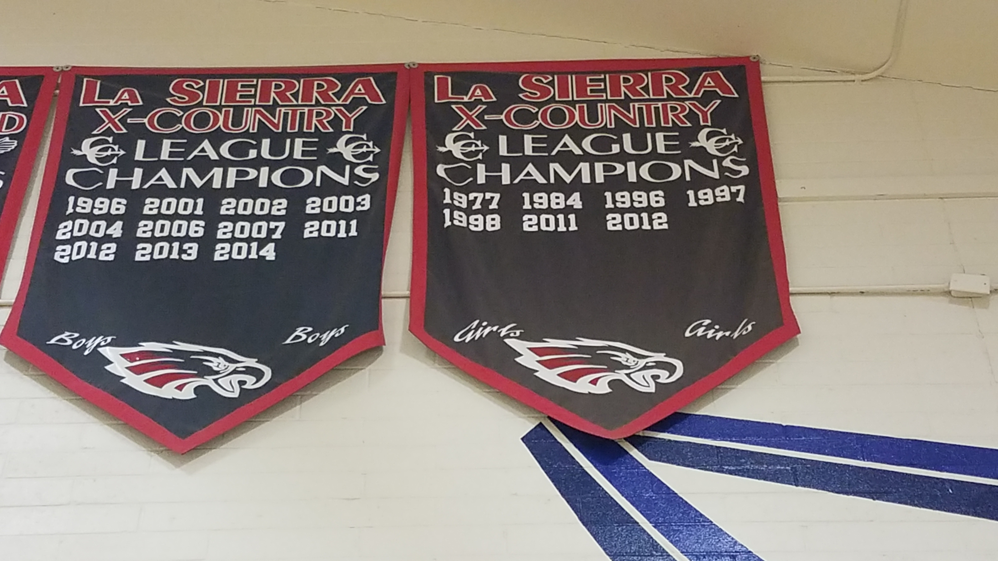

La Sierra Cross Country
Over 29 Years of Success
With over 20 League Titles for Boys and Girls
Boys going 28 straight years to CIF
Girls going 12 Straight years to CIF
Be part of the legacy!!
If interested, first day of Summer Practice will begin June 7, 8, and 10 at 6 pm in room 401. This will be our introduction to Cross Country week. Show up in workout clothes and running shoes!
Must have Health Insurance, Physical Exam, and Parent Permission. Physical Exam paper can be picked up at the main office.
All athletes must fill out their information at www.athleticclearance.com and a properly filled out physical paper picture can be uploaded to the same website, during the creation of an account.
Any further question, please email Coach Solorio at Jrsironman@aol.com or Coach Gray at paul.gray@alvordschools.org

