Comma Review
Sentence Unit III
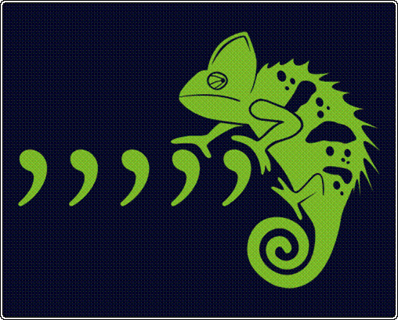

Name: ______________________________

Place commas in the correct locations in each sentence.
Write NC (No Change) next to sentences that do not need to be changed.

How do writers use commas to separate introductory phrases?

- During the first intermission we were able to leave our seats and get a soda.

- After the game we argued about who was the most valuable player.

3. The arena was sold out.

4. In retrospect, it was a great evening for all who attended.

How do writers use commas to separate introductory clauses?

5. After we found our seats we sat down and enjoyed the game.

6. Even though we were far back from the ice, I could see the action easily.

7. The skaters moved the puck fast.

How do writers use commas when there is an interruption in a sentence?

8. You could for example build a sand castle while at the beach.

9. My cousins of course loved the idea.

10. Billy as a matter of fact is a superior sand castle builder.

How do writers use commas with an appositive?

11. Mr. Tumnus a fawn from Narnia felt bad for Lucy.

12. Edmund Lucy’s brother meets the White Witch.

13. Aslan, Narnia’s ruler, greets the children with open arms.

How do writers use commas with explanatory phrases?

14. My father a great cook makes the best burgers.

15. Jen a pretty good chef herself helps in the kitchen.

16. Shelly the family’s food critic loves to sample new treats.

