Comma Quiz
Sentence Unit III
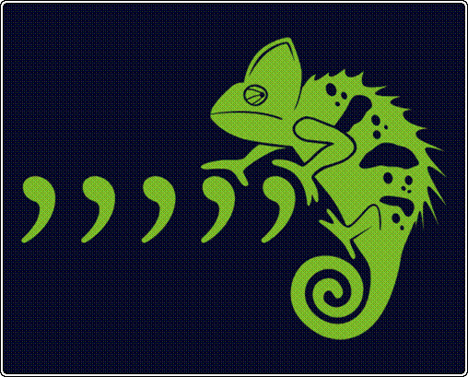

Name: ______________________________

Place commas in the correct locations in each sentence.
Write NC (No Change) next to sentences that do not need to be changed.

How do writers use commas separating introductory phrases?

- In the summer my family takes a few vacations.

- At the beach we spend our days swimming and relaxing.

3. During the morning, we like to get some exercise.

4. In the afternoon, we usually swim until we turn blue.

5. The beach is one of our favorite vacation spots.

How do writers use commas to separate introductory clauses?

6. Even though we like the beach, we also enjoy heading to the mountains.

7. The drive is pretty long to the Adirondack Mountains.

8. If we get there early enough we like to start fishing right away.

9. The fishing in most of the lakes is fantastic.

10. Although the water is fine for swimming we usually fish ten hours a day.

How do writers use commas when there is an interruption in a sentence?

11. My birthday after all is the first day of summer.

12. That day of course is usually hot and humid.

13. We have no choice therefore but to go swimming.

14. If the weather is bad however we won’t go near the ocean.

15. Last year for example it rained all day.

How do writers use commas with an appositive?

16. Our class president Blake Bednarz gave a great speech.

17. Katie Stevens the vice president gave a tremendous presentation.

18. Fred Fillmore Treasurer of Fillmore School provided his ideas during the meeting.

19. Tim Conway, the school historian, videos and photographs each school event.

20. Mr. Brooks the student council advisor attends all the meetings.

How do writers use commas with explanatory phrases?

21. Mr. Brennan a regular customer visits our store weekly.

22. The store which has been around for thirty years has some of the best buys in town.

23. The Presidents’ Day sale back by popular demand begins Saturday.

24. The owner who has lived in town his whole life runs a good business.

25. The mayor who lives in town also loves to shop on Main Street.

